**24/08/25**

**CSS web layout  
  
flexboxes, grids, boxes  
helps to modify the font, colors , layouts, size  
  
display property  
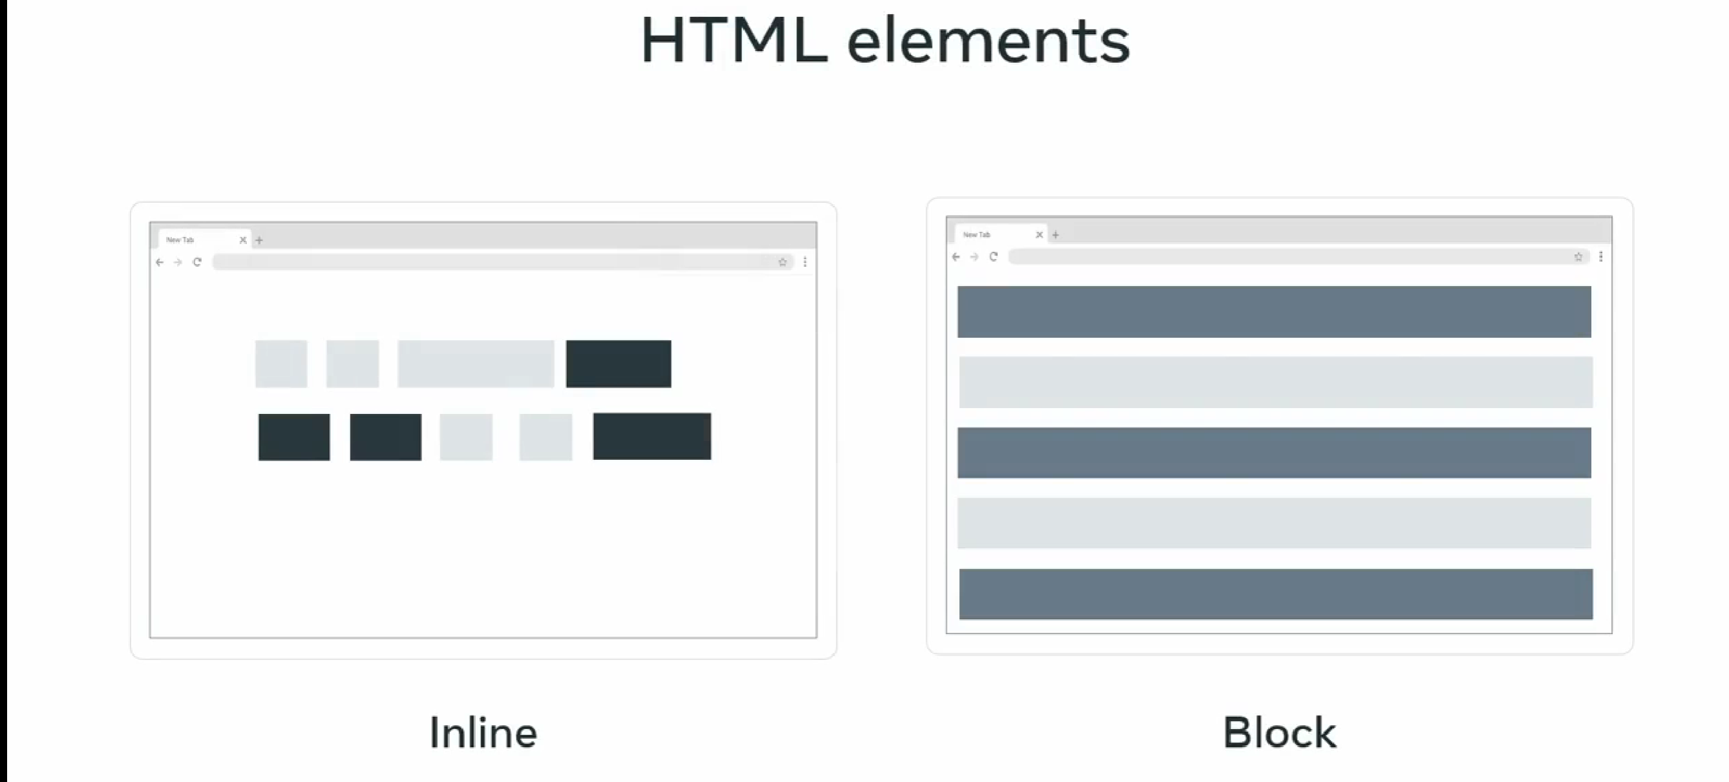  
  
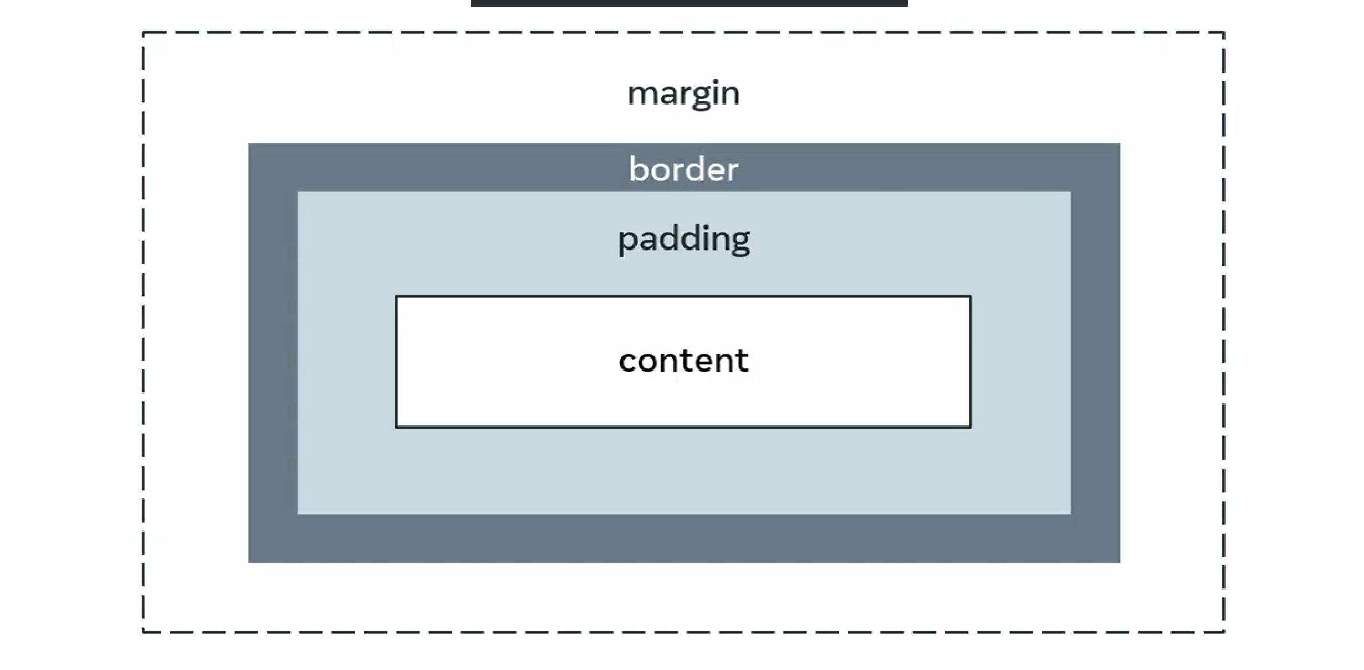**

**For id value sample**

**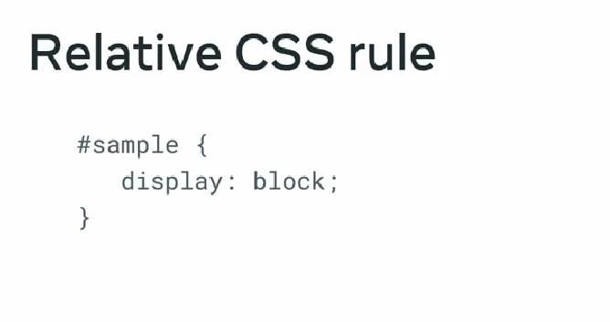  
  
flex box 1D  
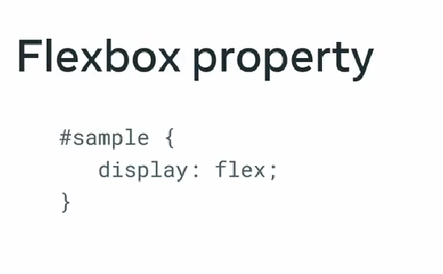**add responsiveness float elements positioning.  
arrange item either in column or row wise along it’s access  
  
**flexbox suits for small-scale  
  
  
grid 2D  
  
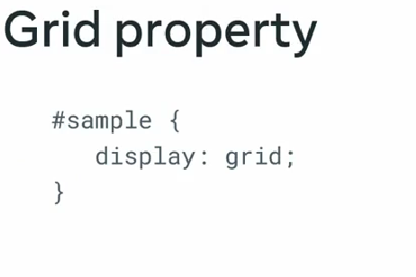  
  
grid suits for large scale**

**Flexbox is single-dimensional, which means you can align it either along a row or a column and it is set to row alignment by default. There are two axes, the main and cross-axis, much like the x and y-axis used in coordinate geometry. When aligned along the row, the horizontal axis is called the main axis and the vertical axis is called the cross axis. For the items present inside the flexbox container, the placement starts from the top-left corner moving along the main or horizontal axis. When the row is filled, the items continue to the next row. Note that with the help of a property called flex-direction, you can instead flip the main axis to run vertically and the cross axis will then be horizontal. In such a case, the items will start from top left and move down along the vertical main axis. The properties you choose will help better control alignment, spacing, direction and eventually styling of the container and items present inside it.   
  
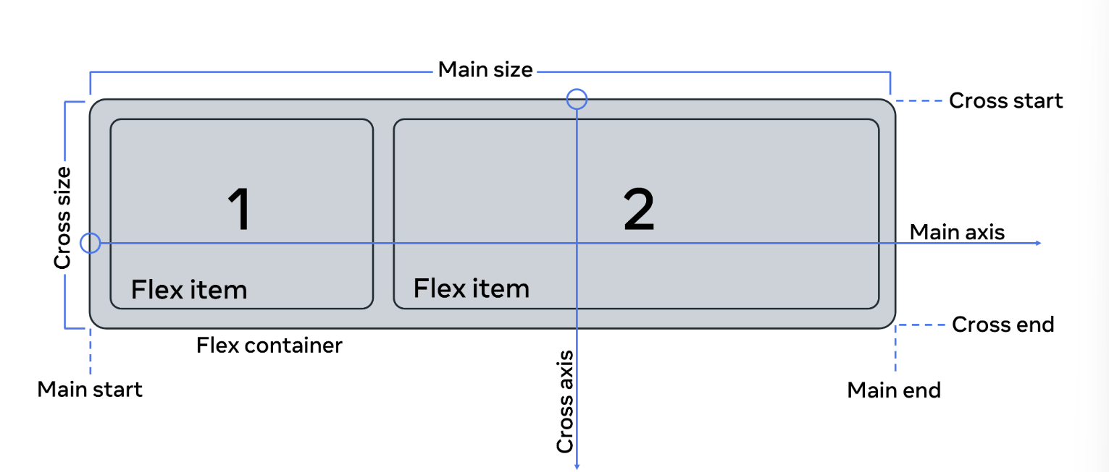  
  
CSS units of measurement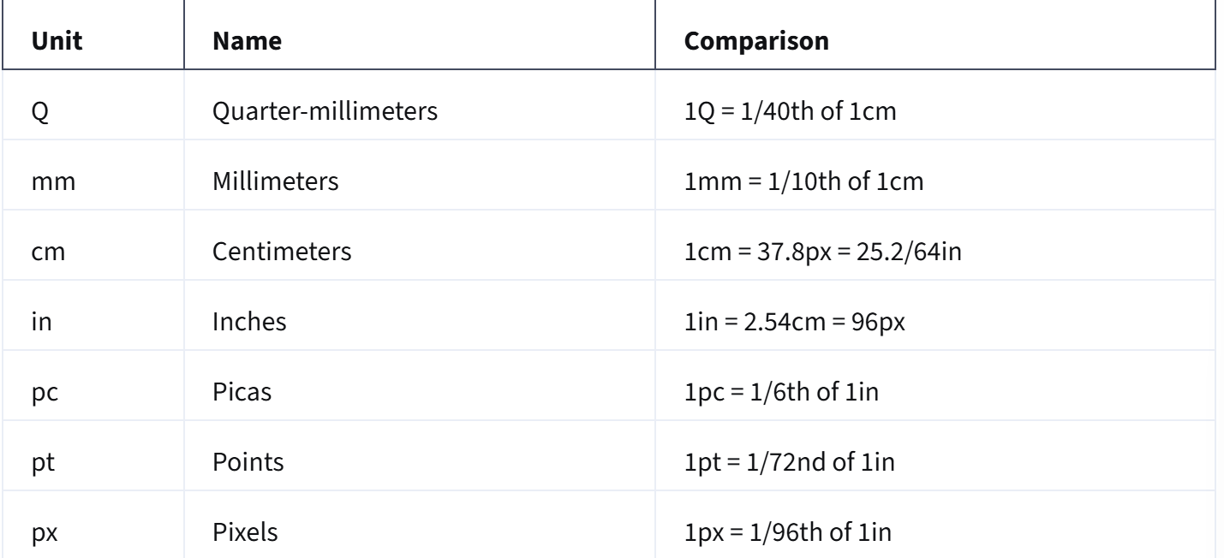 Relative values**

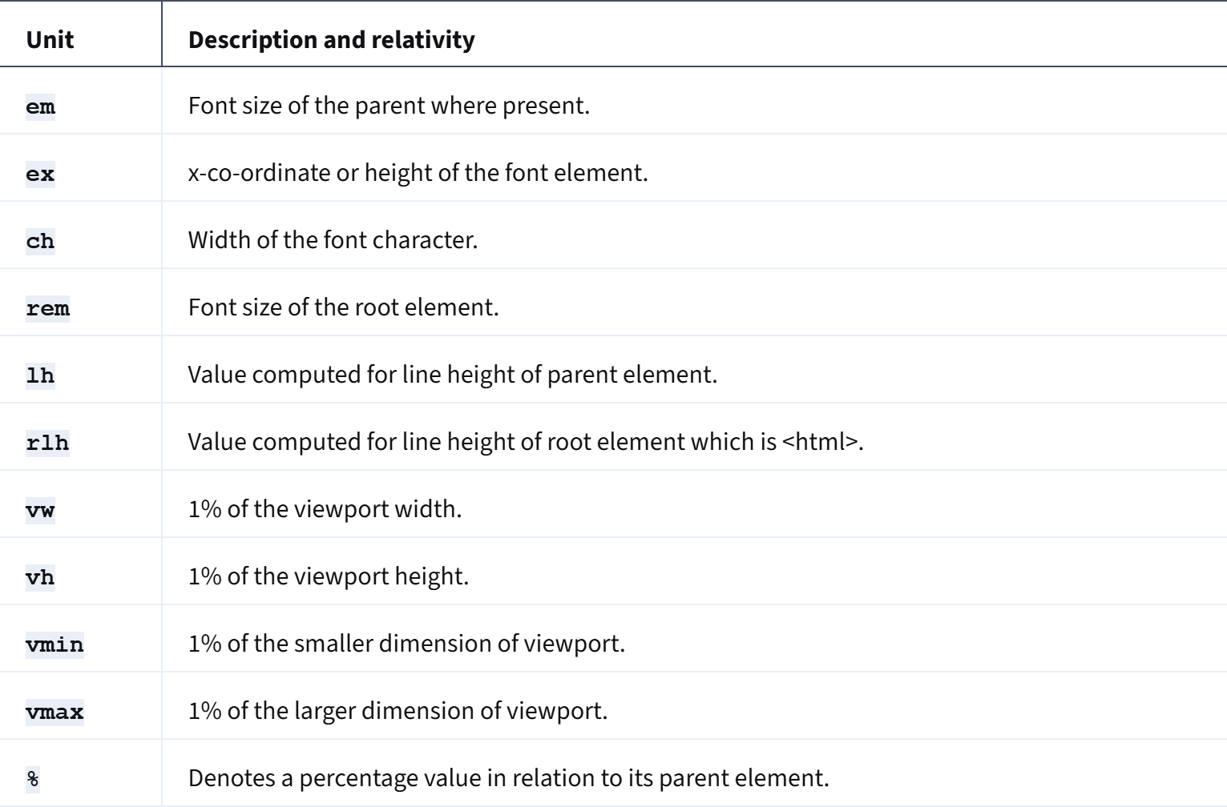  
  
**backgroundcolor** will have values such as hexadecimal, **rgb()**, **rgba()**, **hsl()**, **hsla()**

**basic flex box**search bar  
navigation bar  
image gallery

margin: 0 25px;  
  
This is shorthand for **top/bottom** and **left/right** margins.

* The first value (0) → applies to **top** and **bottom**.
* The second value (25px) → applies to **left** and **right**.

**Flex charts  
  
using flex chat to create bar chat  
can generate vertical or horizontal bar charts.  
flex grow, flex shrink, flex basics  
  
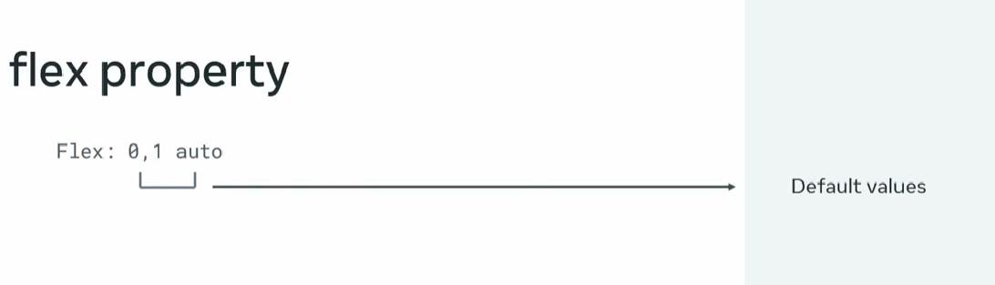  
  
short cut  
type .row then press enter  
  
<div class="row"></div>**

**CSS grids  
2D design layout.  
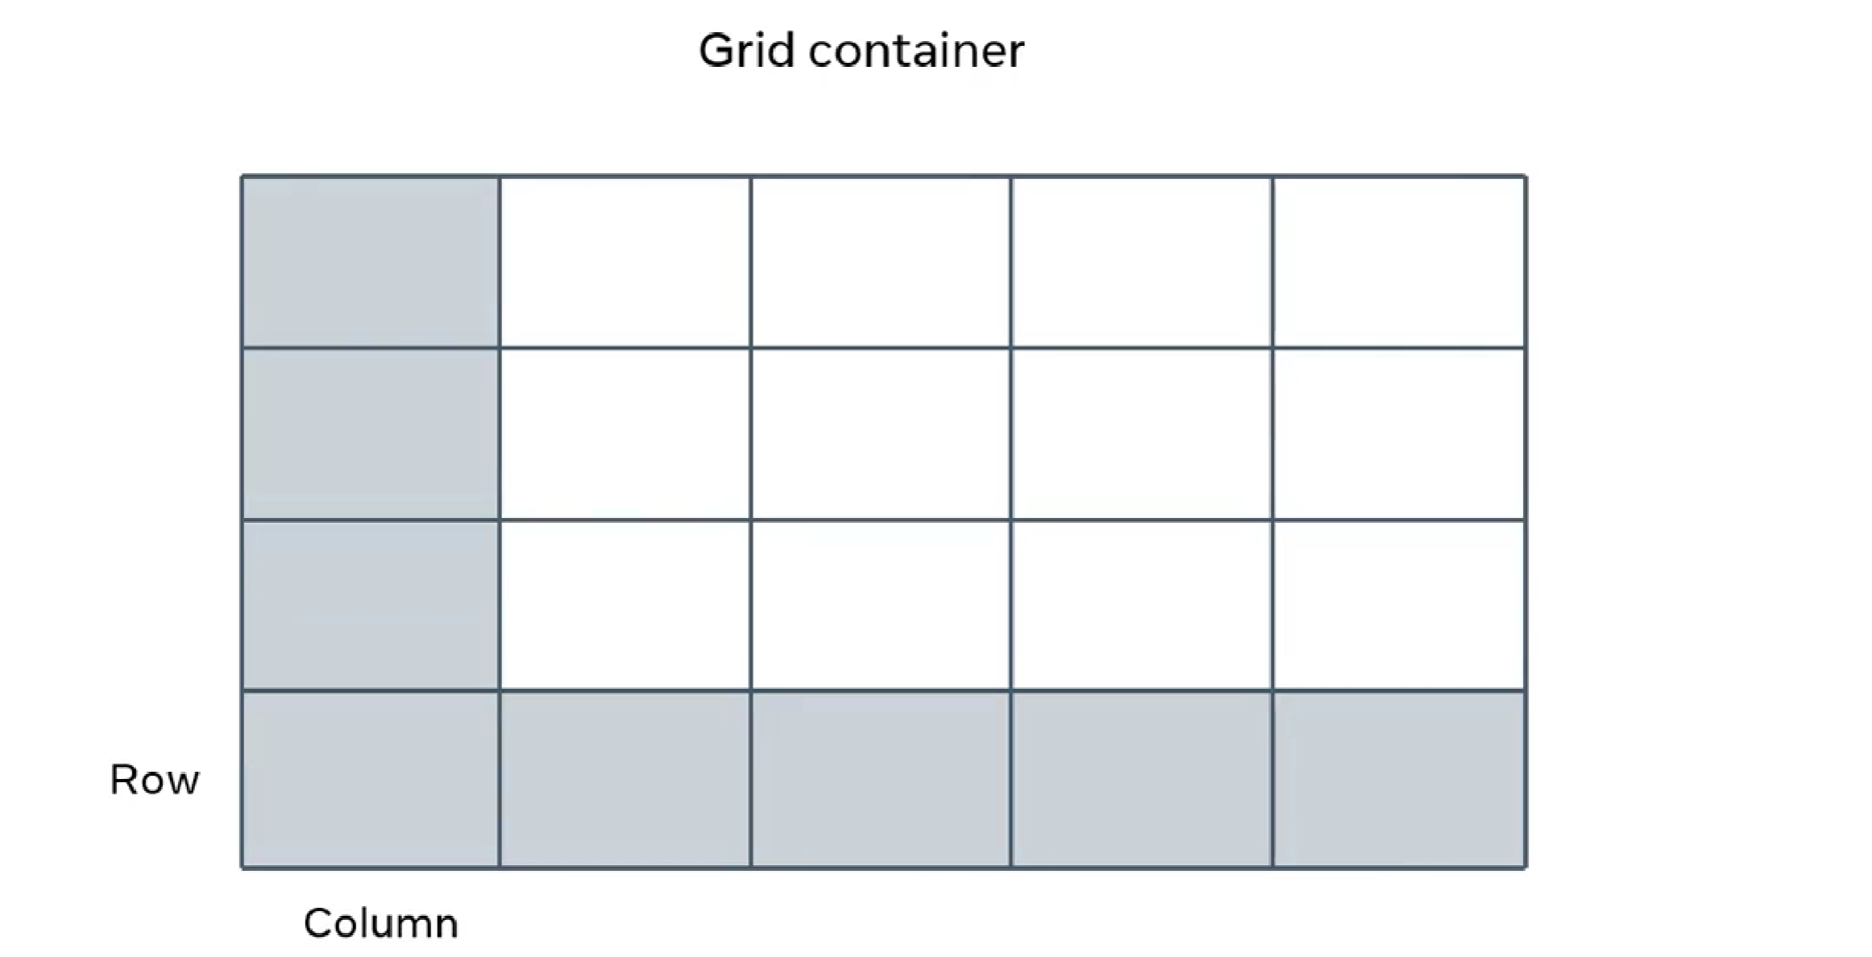  
  
grid cell is the single cell  
12 column grid  
  
grid template area  
  
What is grid-template-areas?**

**It’s like drawing a map of your layout using words.  
Each word = one box in the grid.  
Each row of words (inside quotes " ") = one row of the grid.**

**Your code:**

**grid-template-areas:**

**"head head"**

**"nav main"**

**"footer footer";**

**👉 This means:**

1. **"head head" → first row has 2 boxes, both named head**
   * **So the header will stretch across the whole top row.**
2. **"nav main" → second row has 2 boxes:**
   * **left side is nav**
   * **right side is main**
3. **"footer footer" → third row has 2 boxes, both named footer**
   * **So the footer will stretch across the whole bottom row.**

**Easy picture:**

**Row 1: [ head | head ] → header across full width**

**Row 2: [ nav | main ] → nav left, main right**

**Row 3: [ footer | footer ] → footer across full width**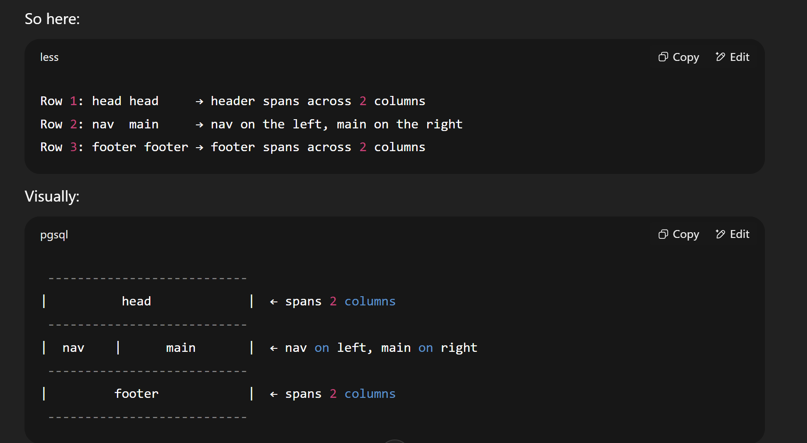

Additional resources  
  
https://csslayout.io/  
  
https://1stwebdesigner.com/fascinating-css-grid-layout-examples-and-tutorials/  
  
https://www.educba.com/css-viewport/  
  
https://web.dev/learn/css/grid/  
  
https://learncssgrid.com/  
  
https://css-tricks.com/snippets/css/a-guide-to-flexbox/  
  
<https://developer.mozilla.org/en-US/docs/Learn/CSS/CSS_layout>  
  
**css selectors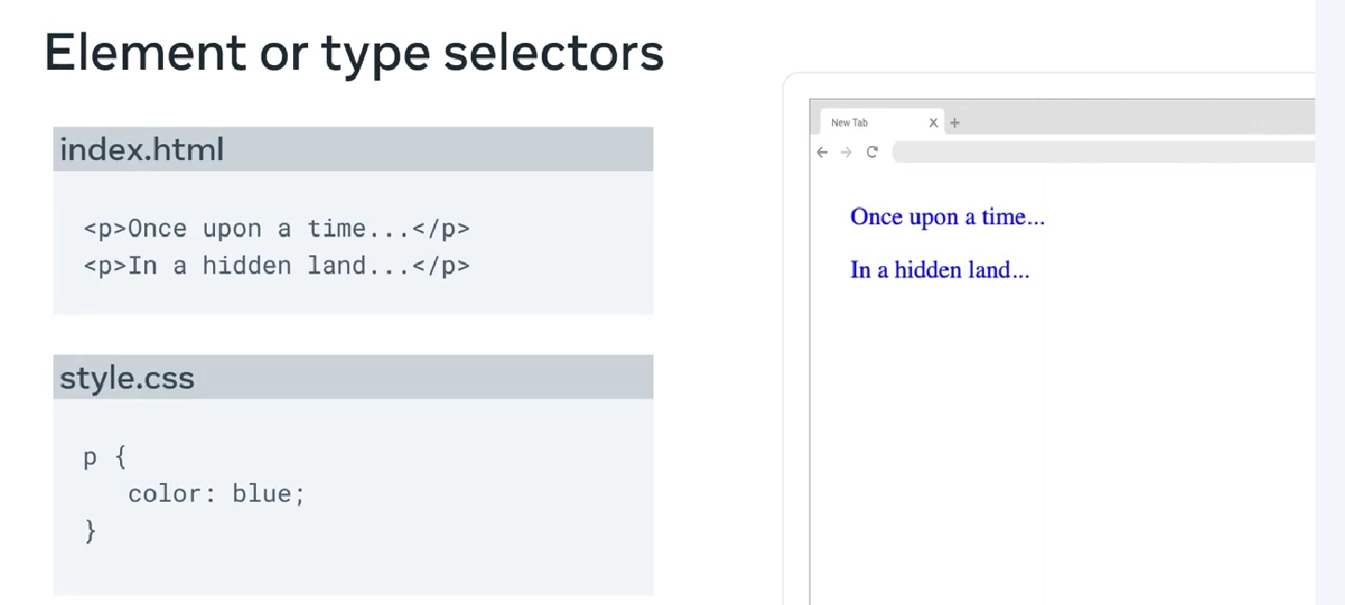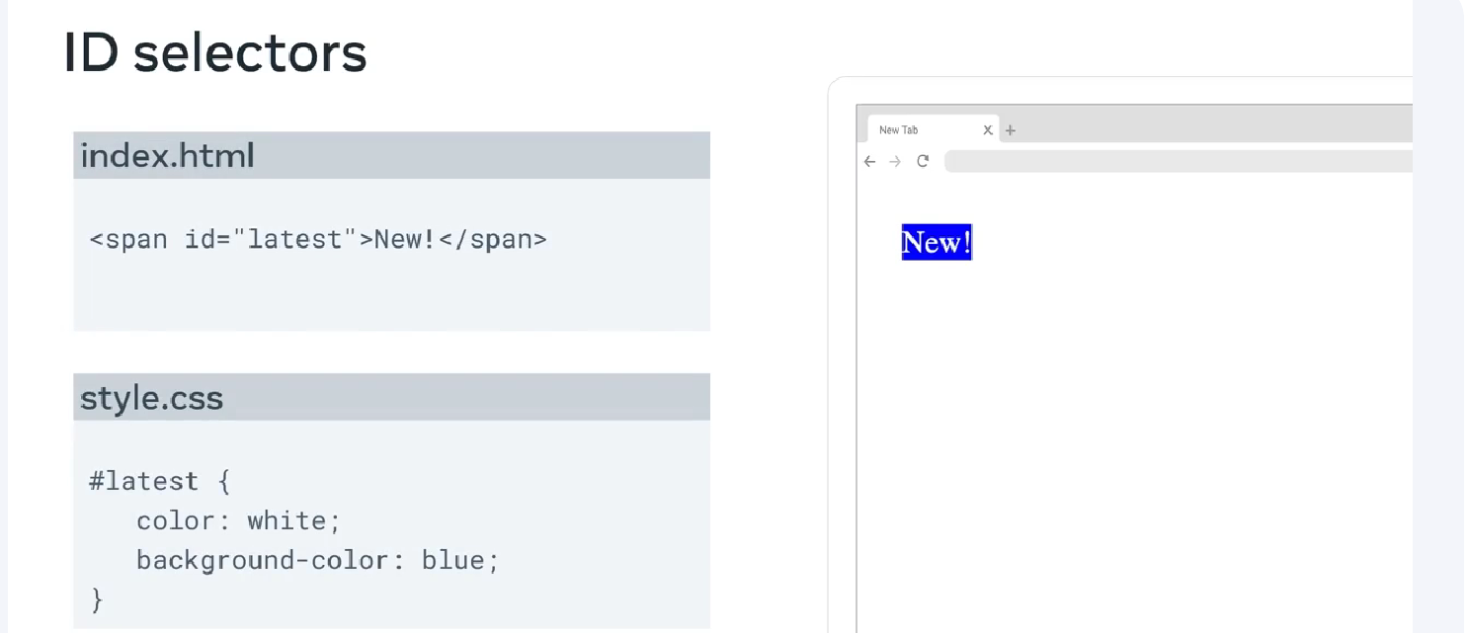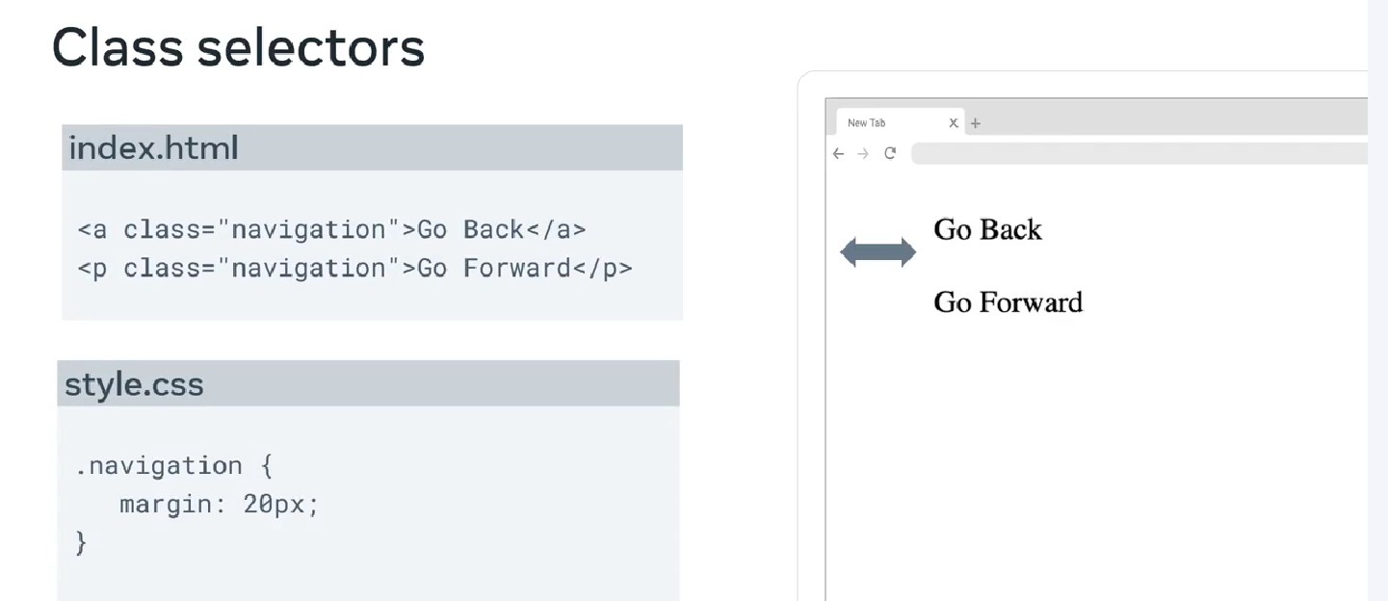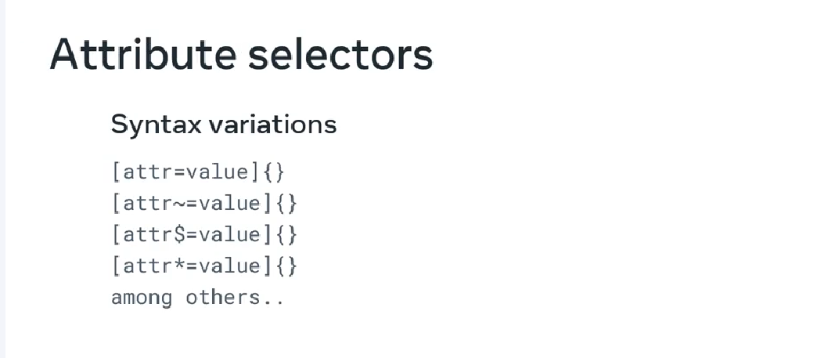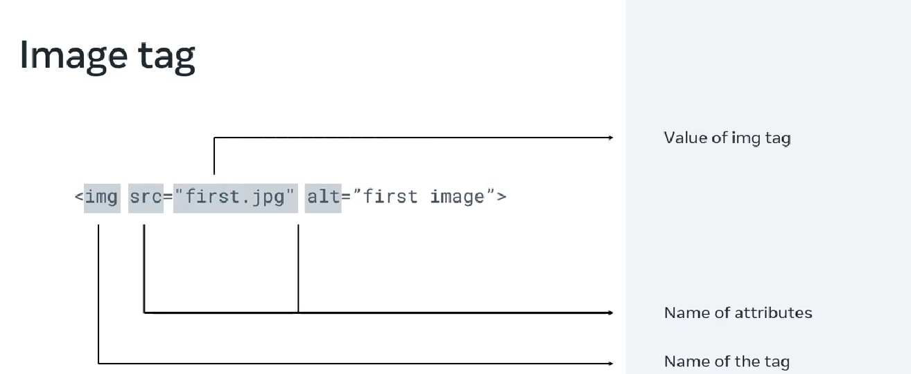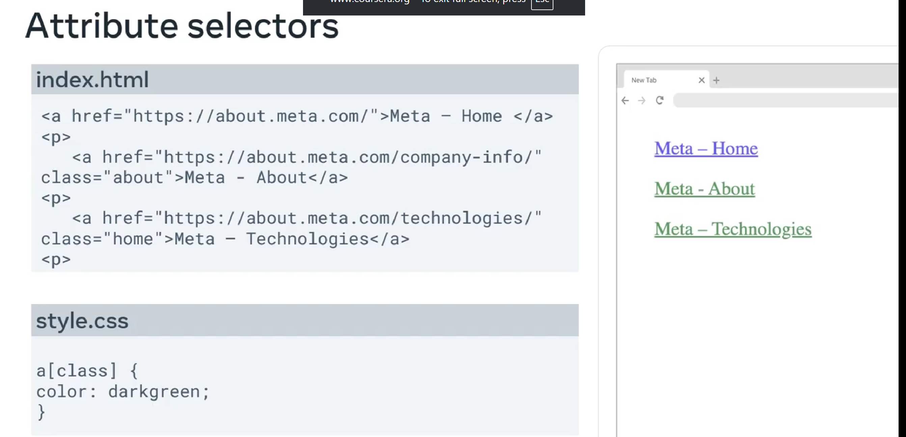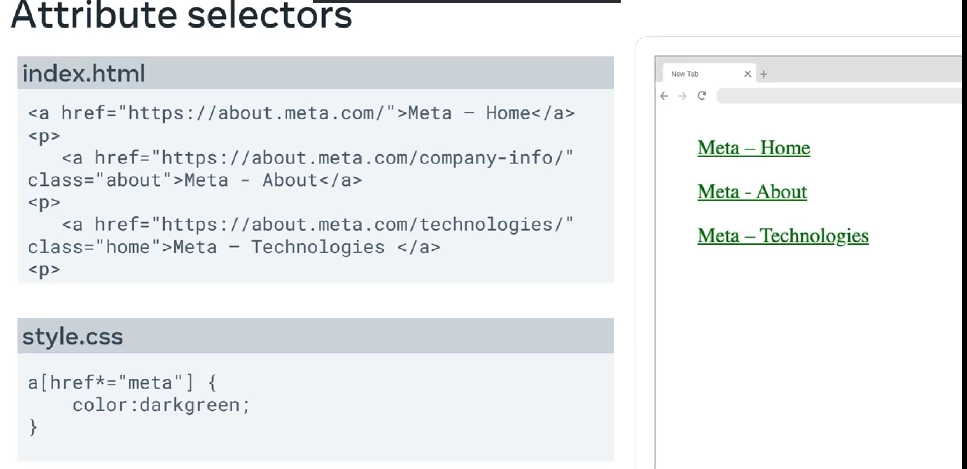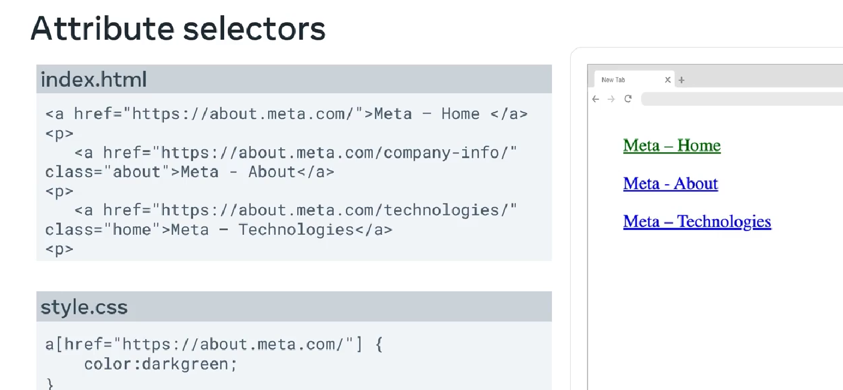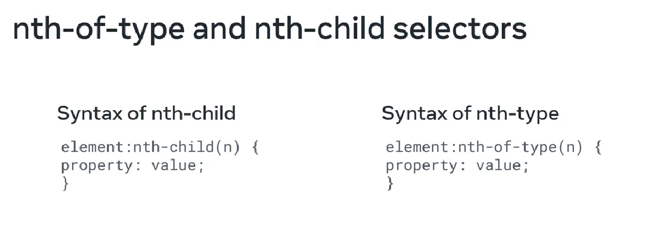 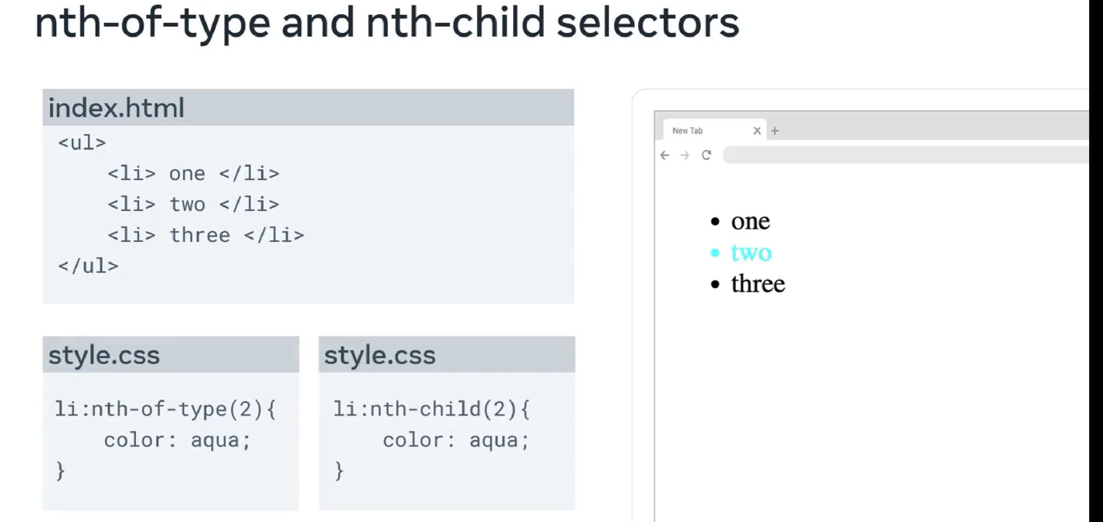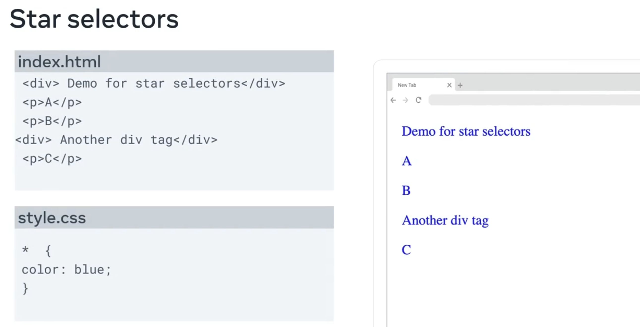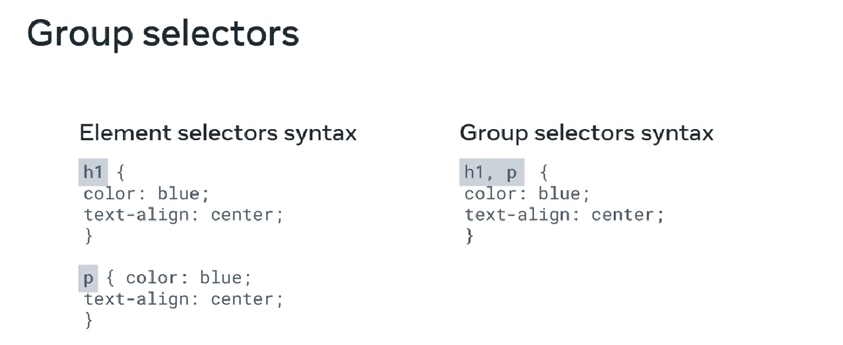 combination selectors**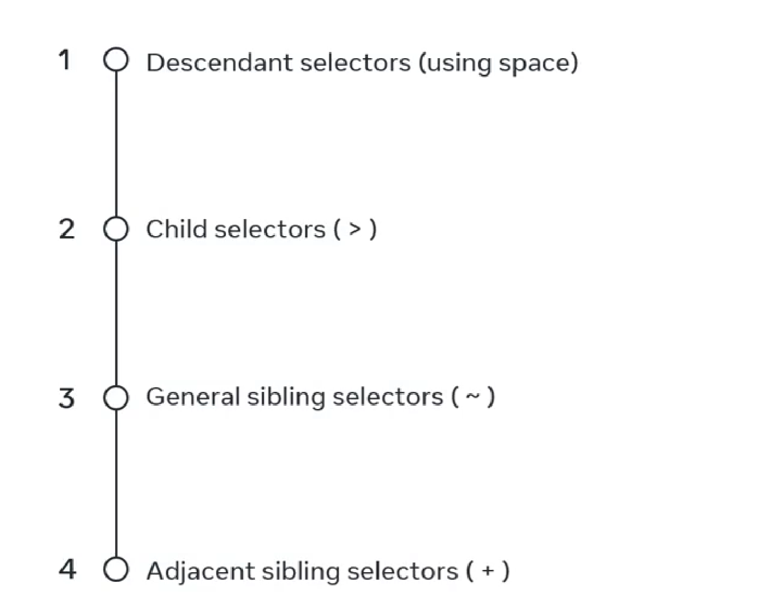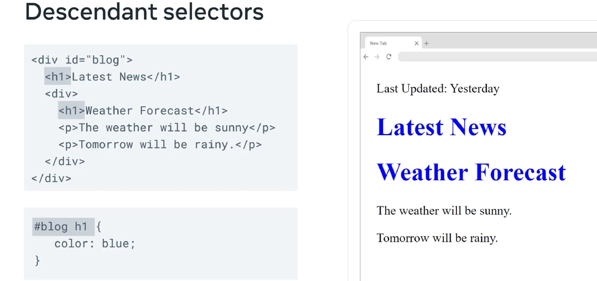

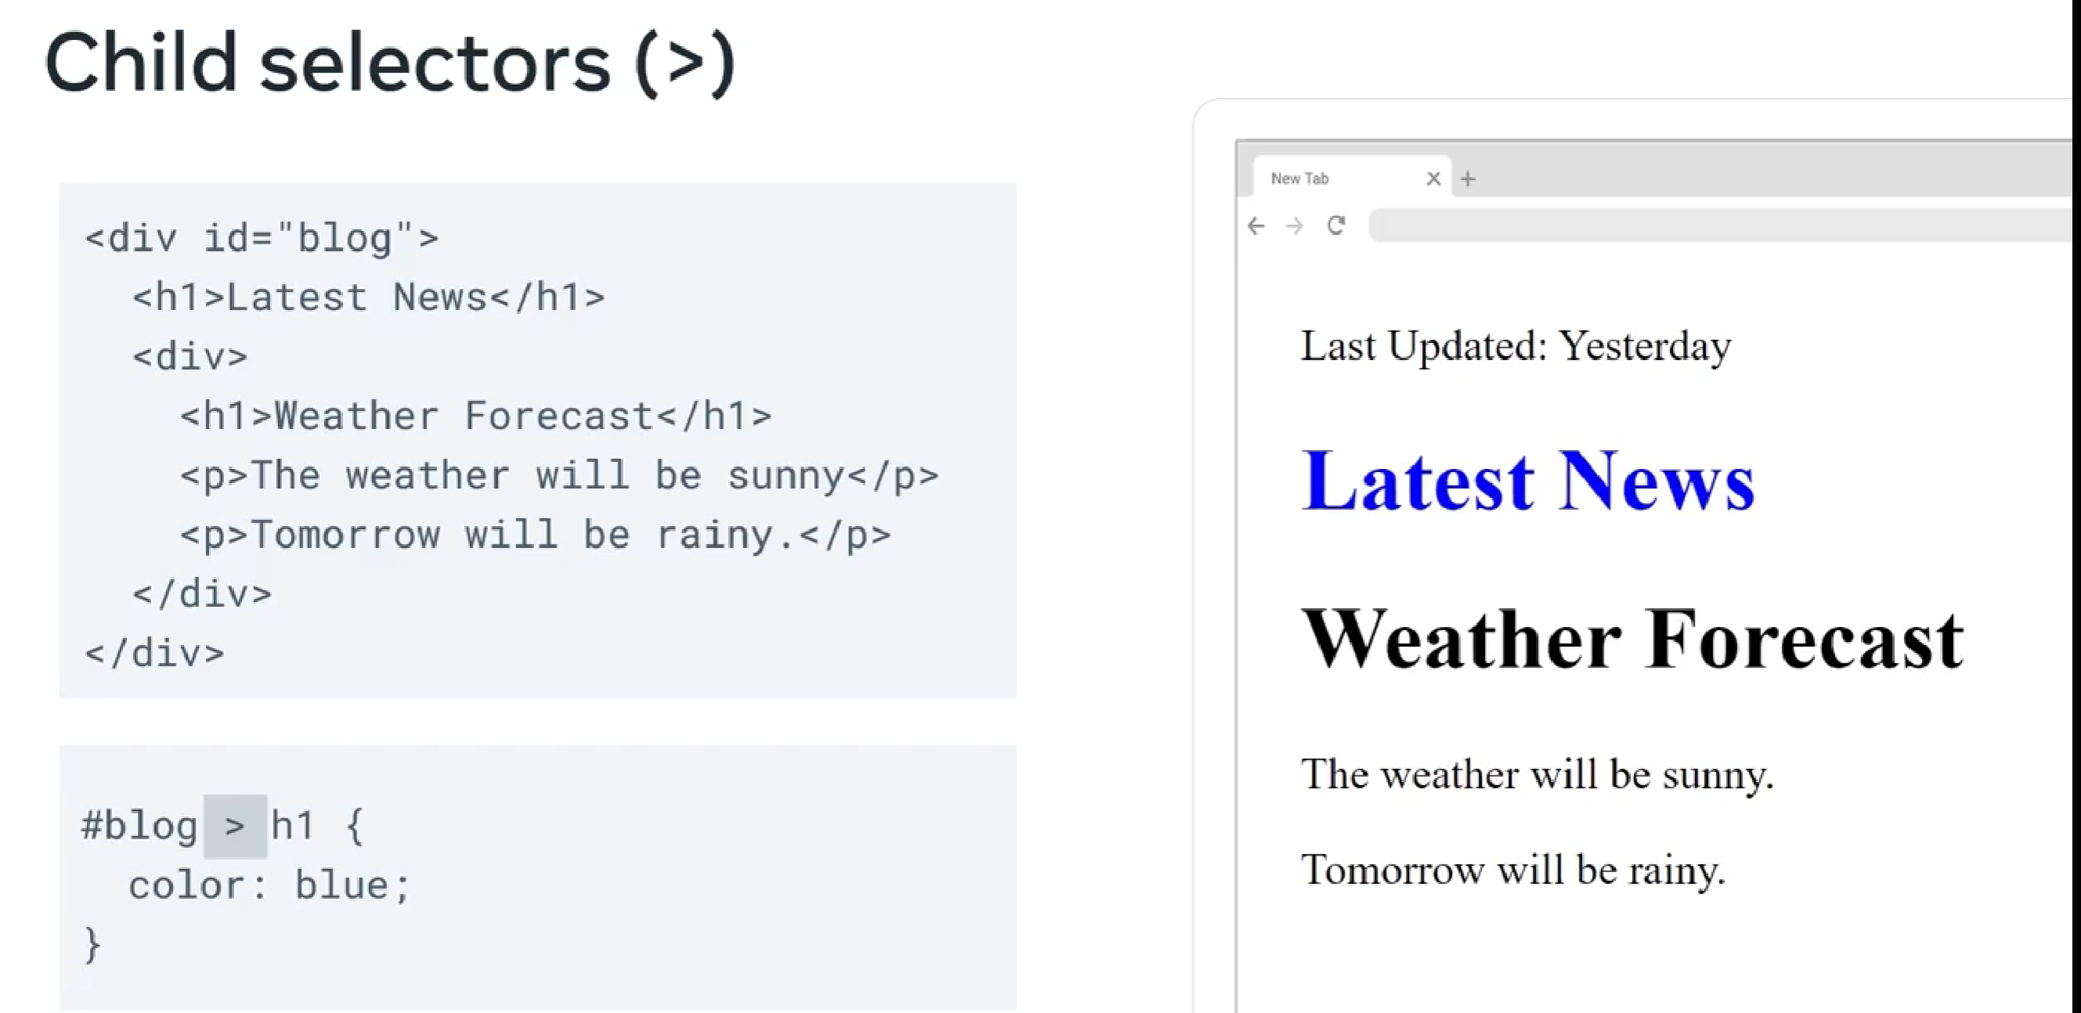  
bolg > only child h1  
  
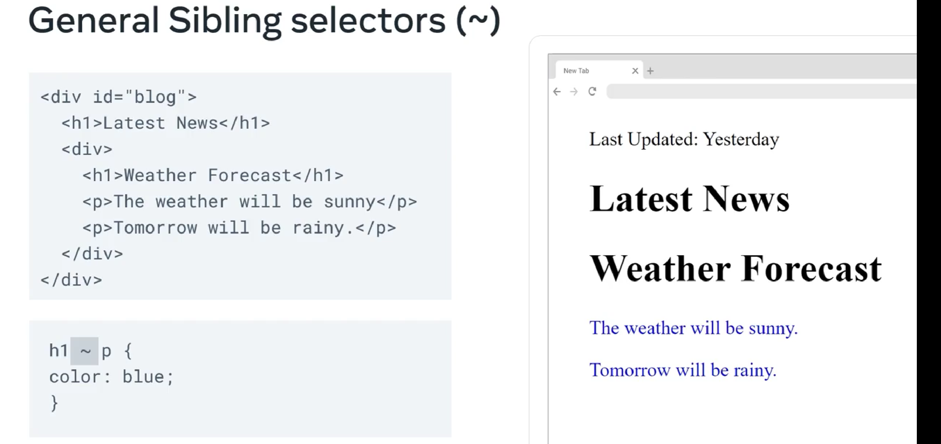  
check the siblings of h1 with paragraph  
  
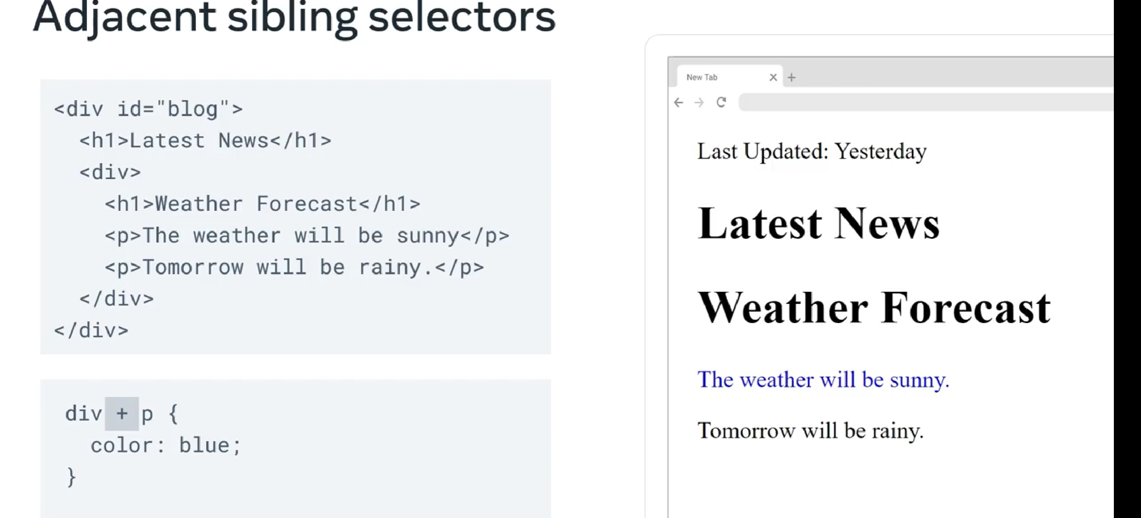  
  
only select the first subsequent element that is matches.  
  
25/08/2025  
  
**pseudo class selectors**  
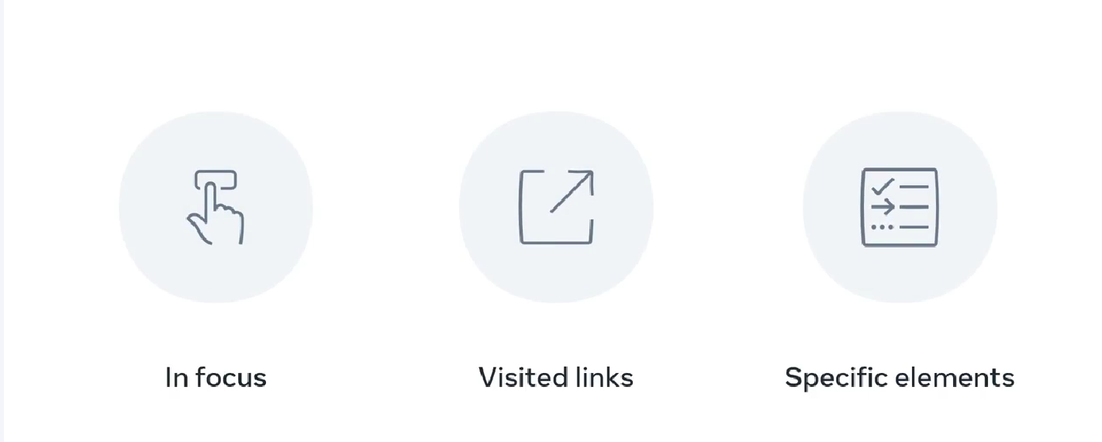  
user action state  
:hover  
:active  
:focus  
  
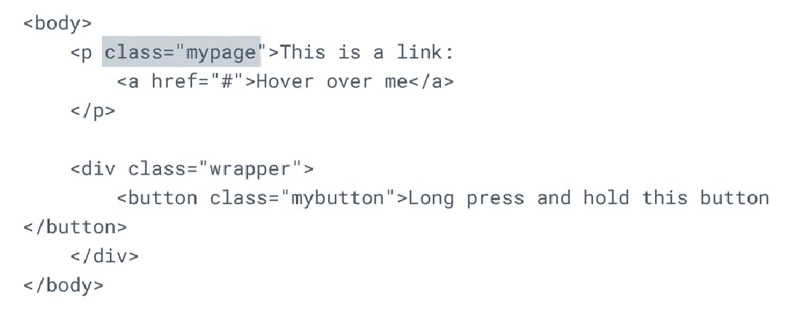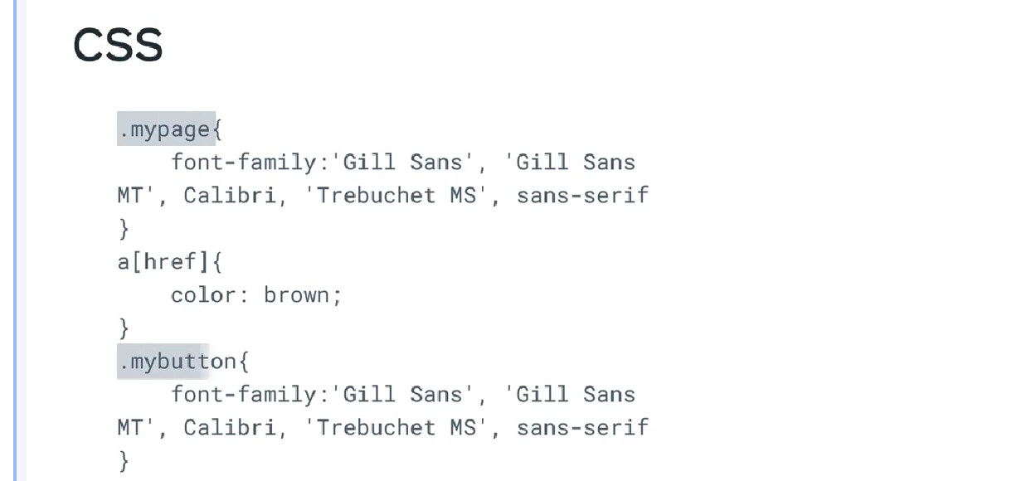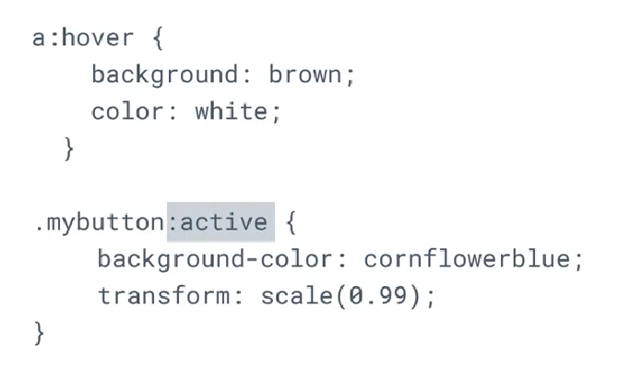

**form states  
  
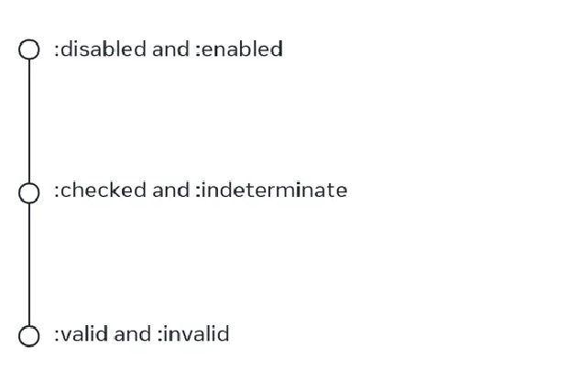**

**specific position based states  
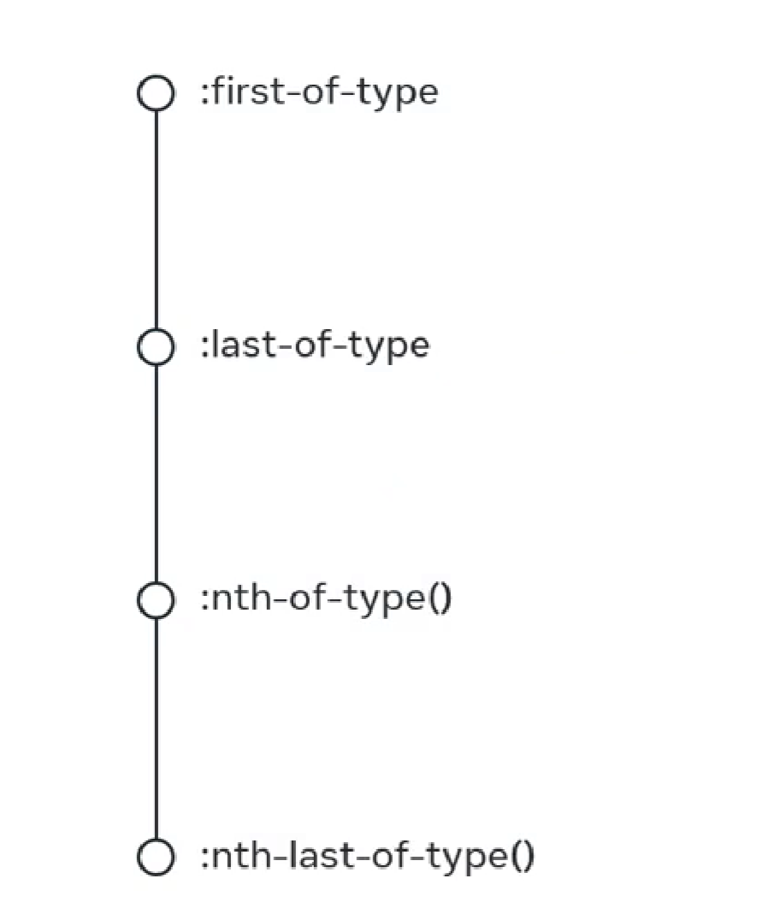  
  
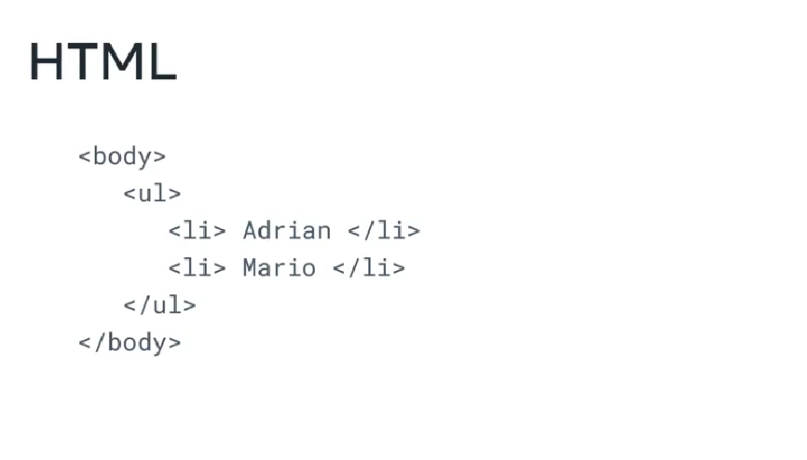  
  
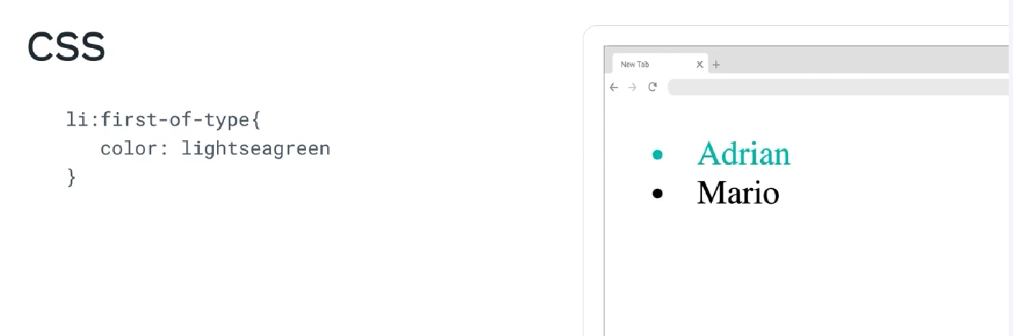**

practical use of pseudo  
  
web-link states  
  
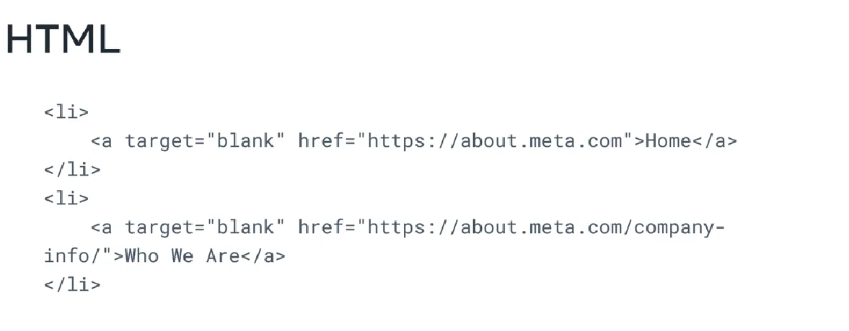  
  
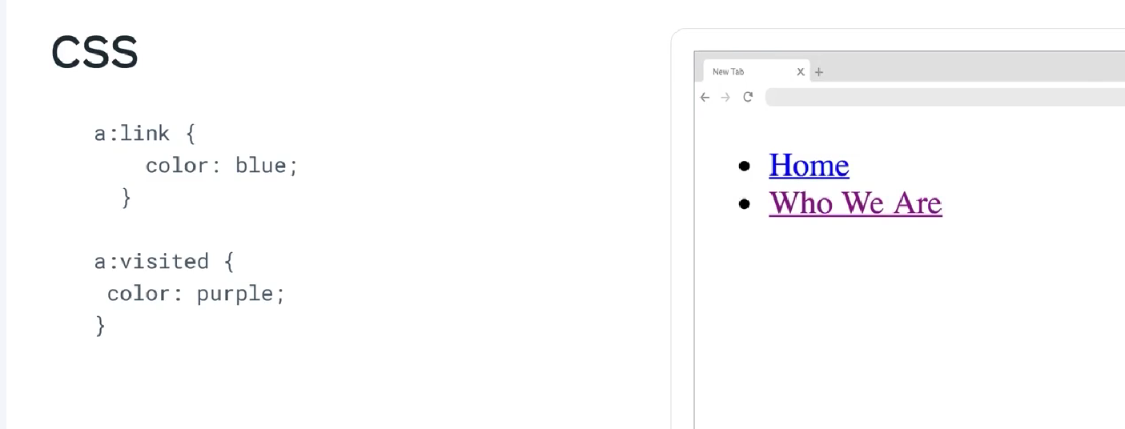  
  
**LVHA  
  
link, visited, hover, active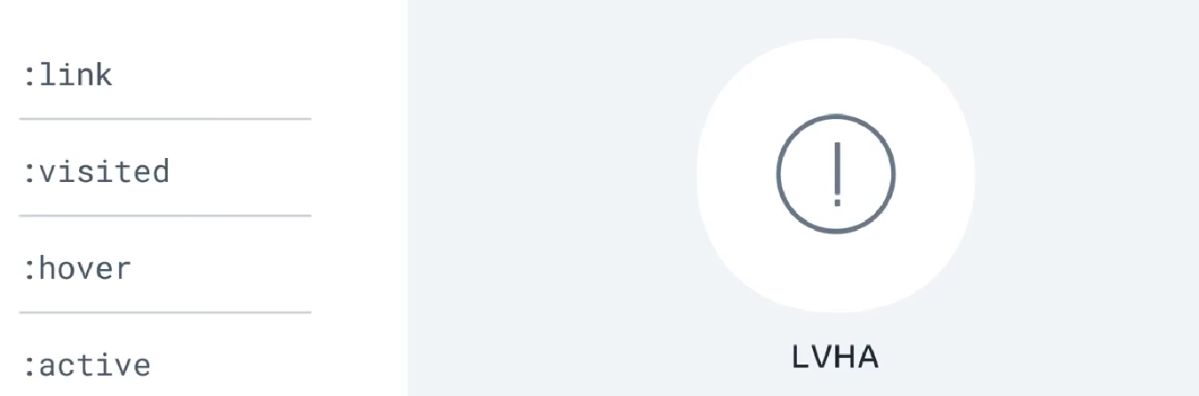 follow this always to apply css  
  
cheat sheet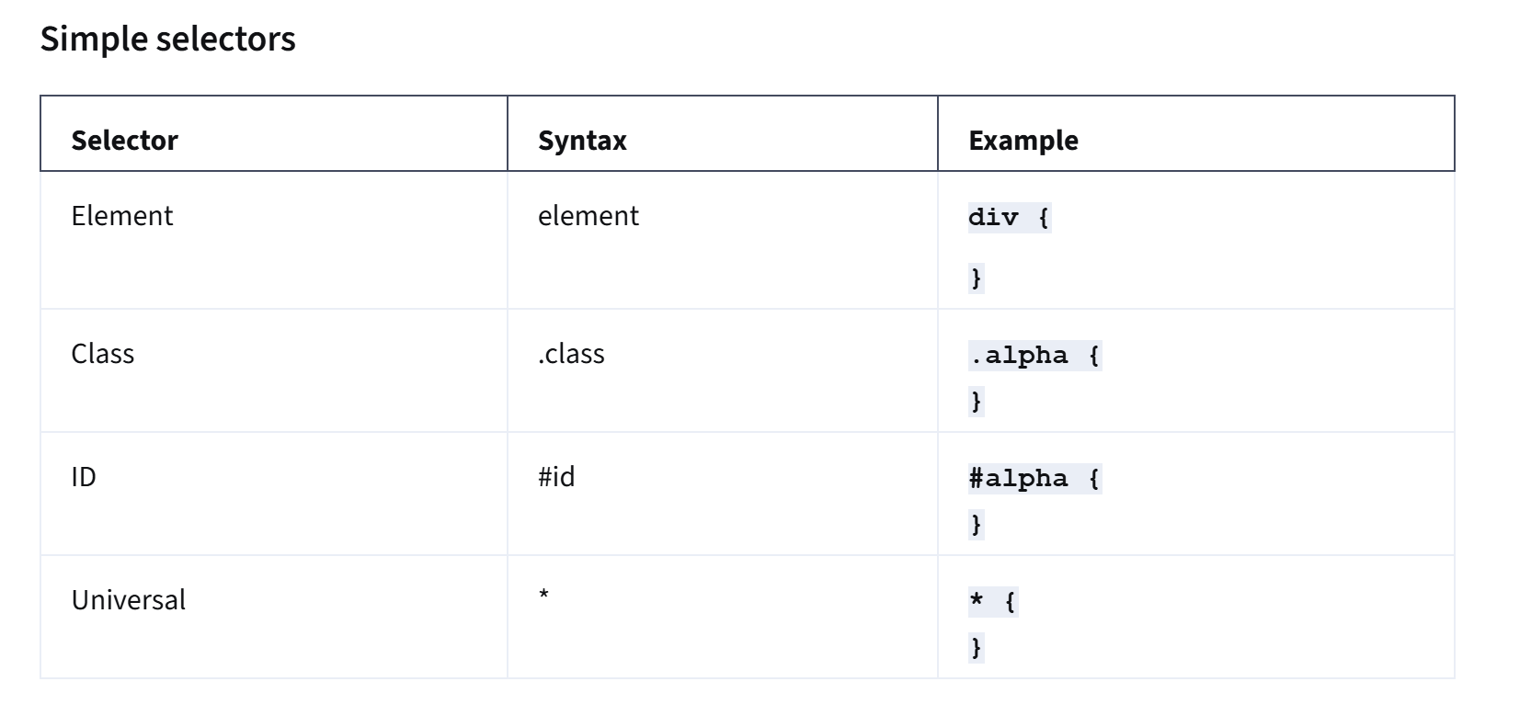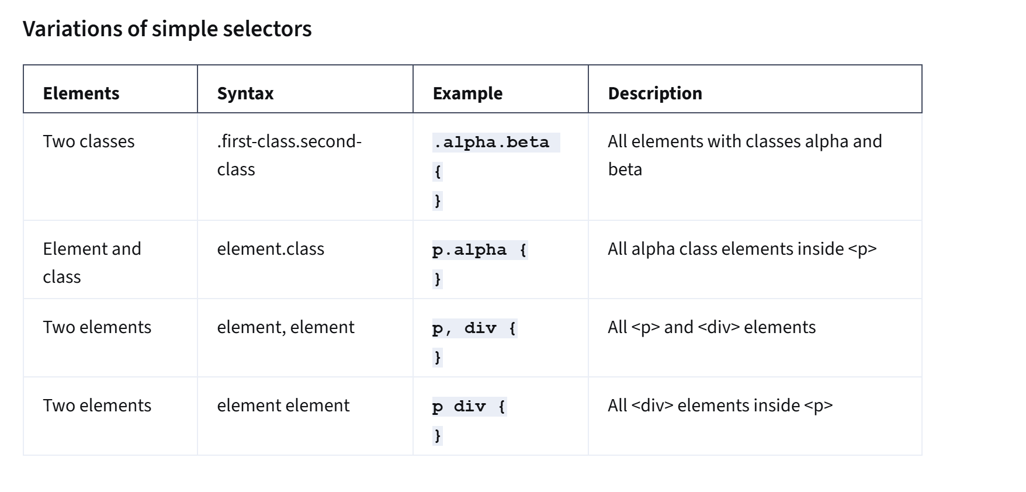  
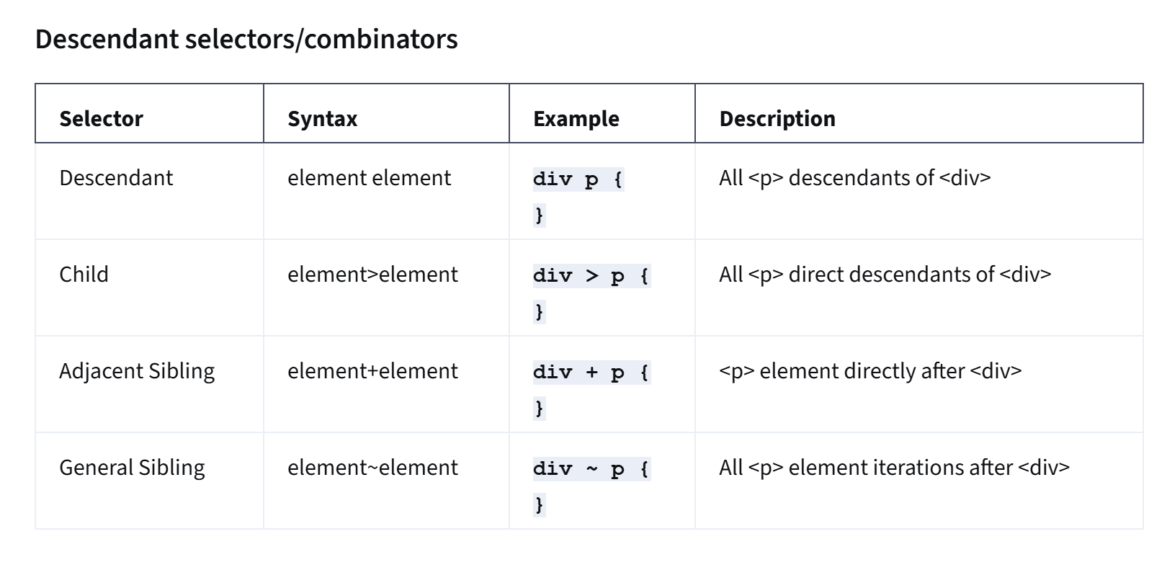  
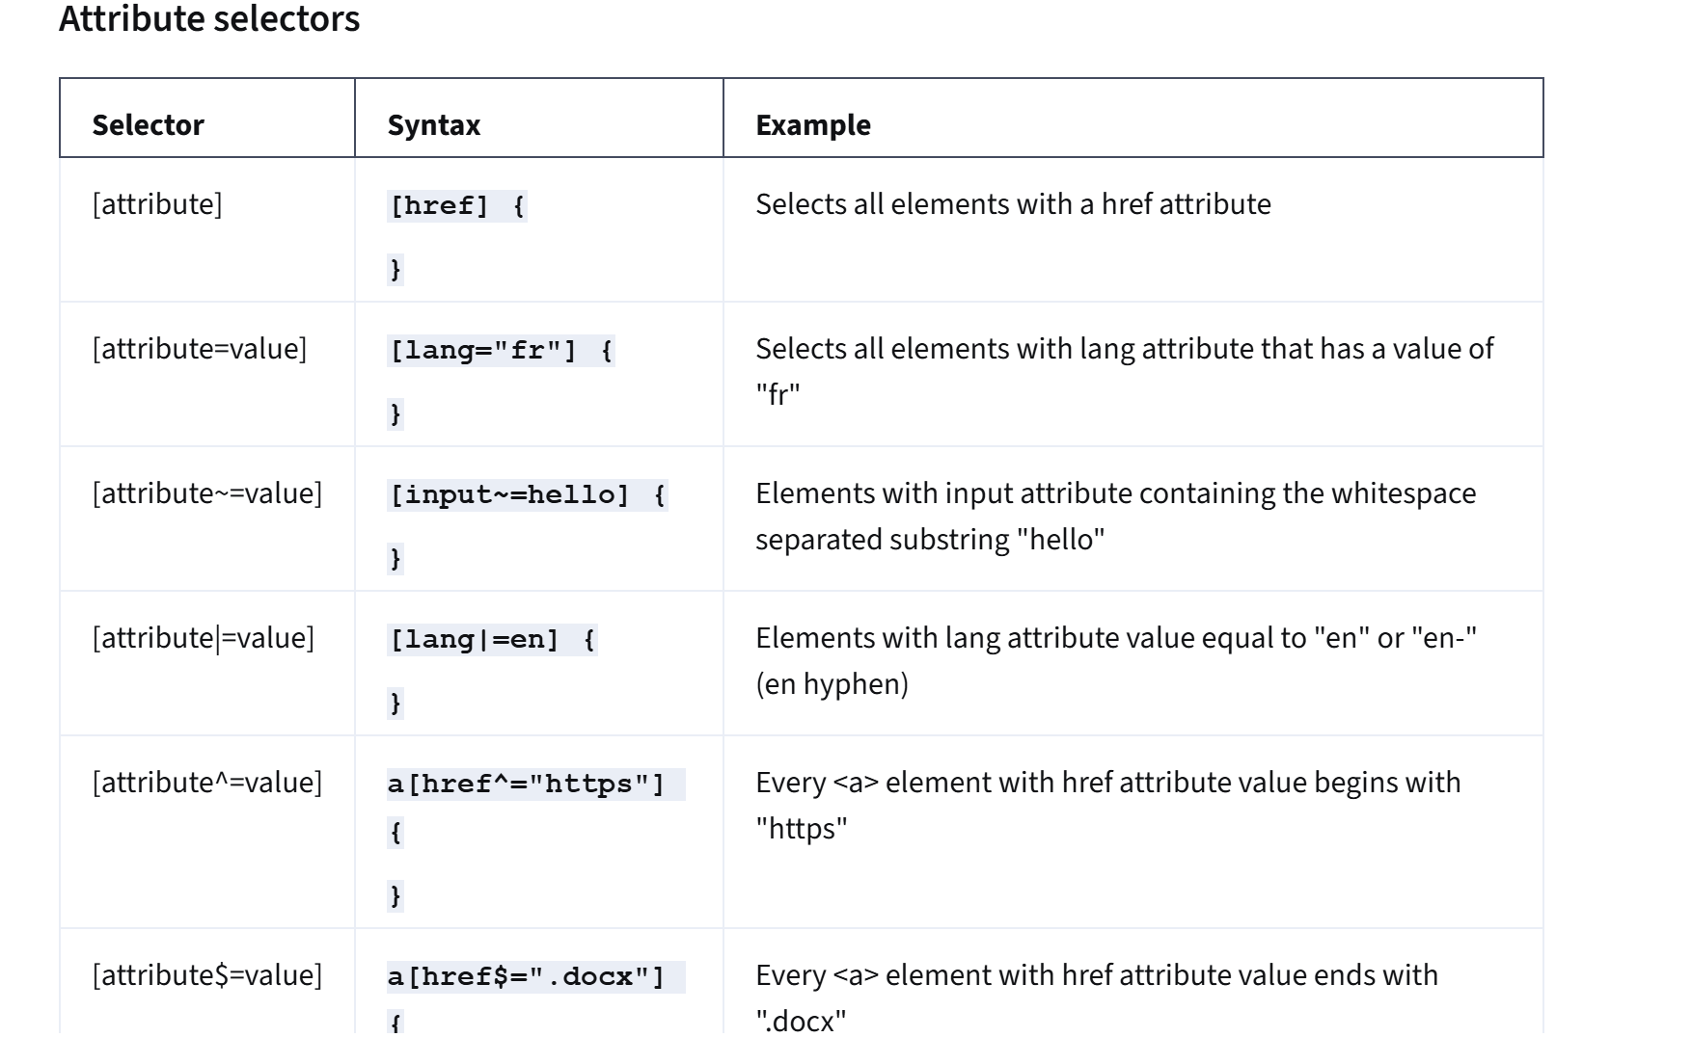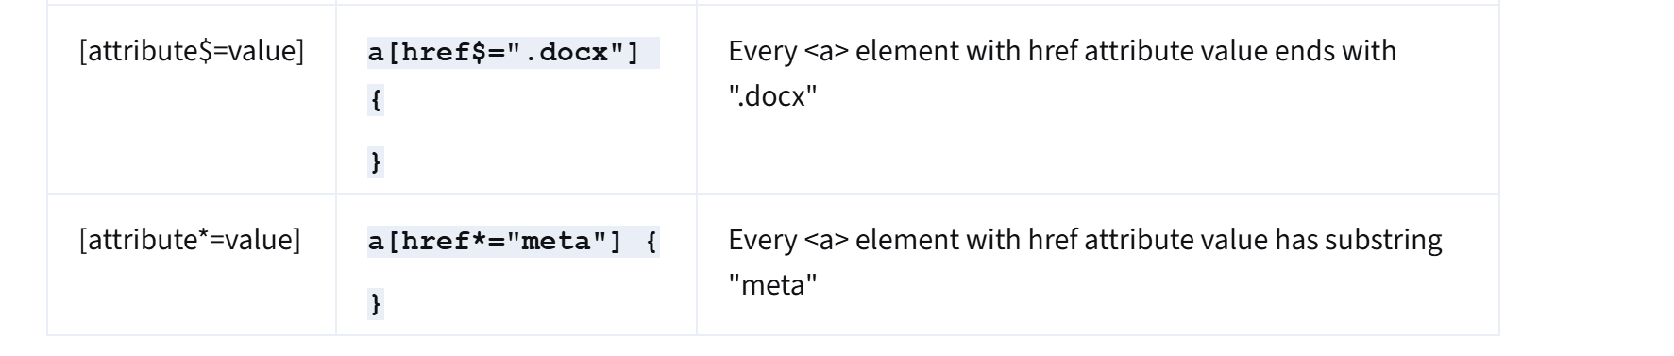  
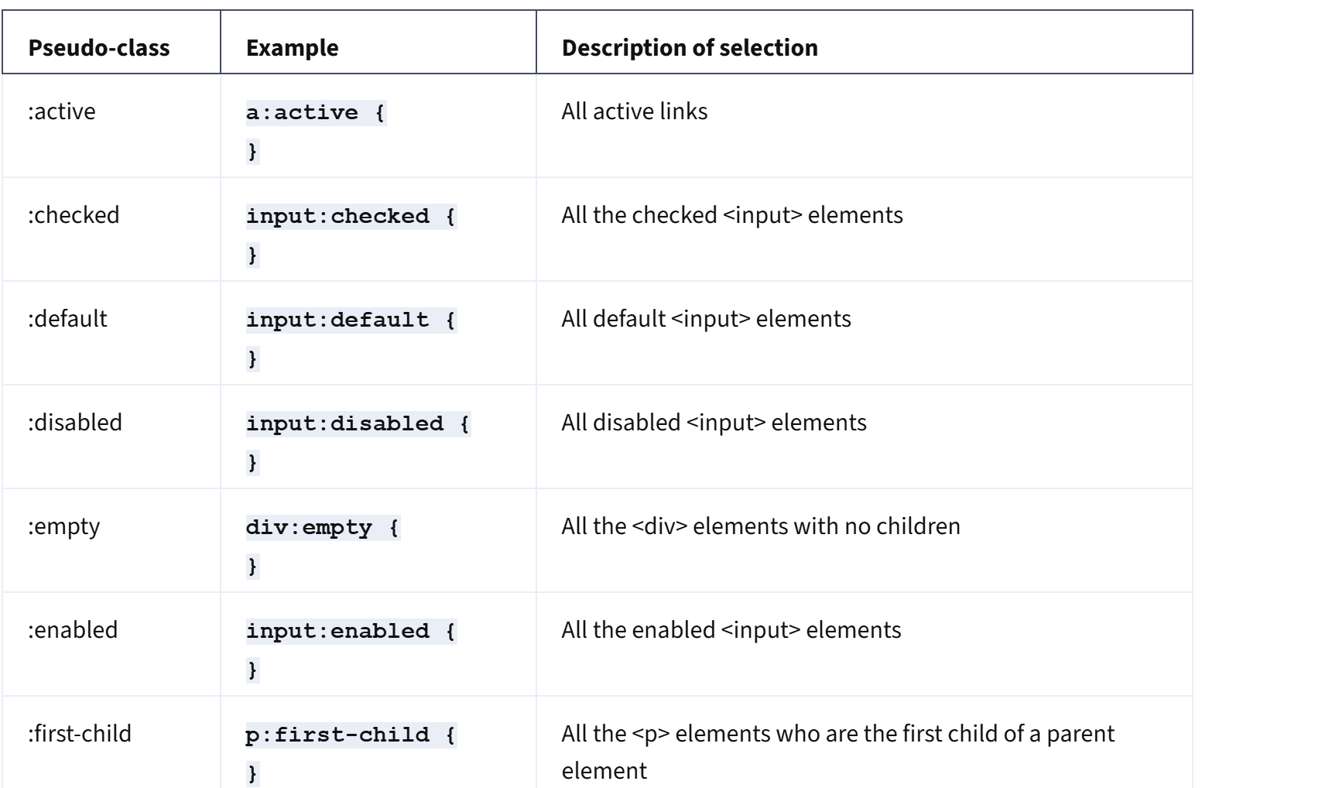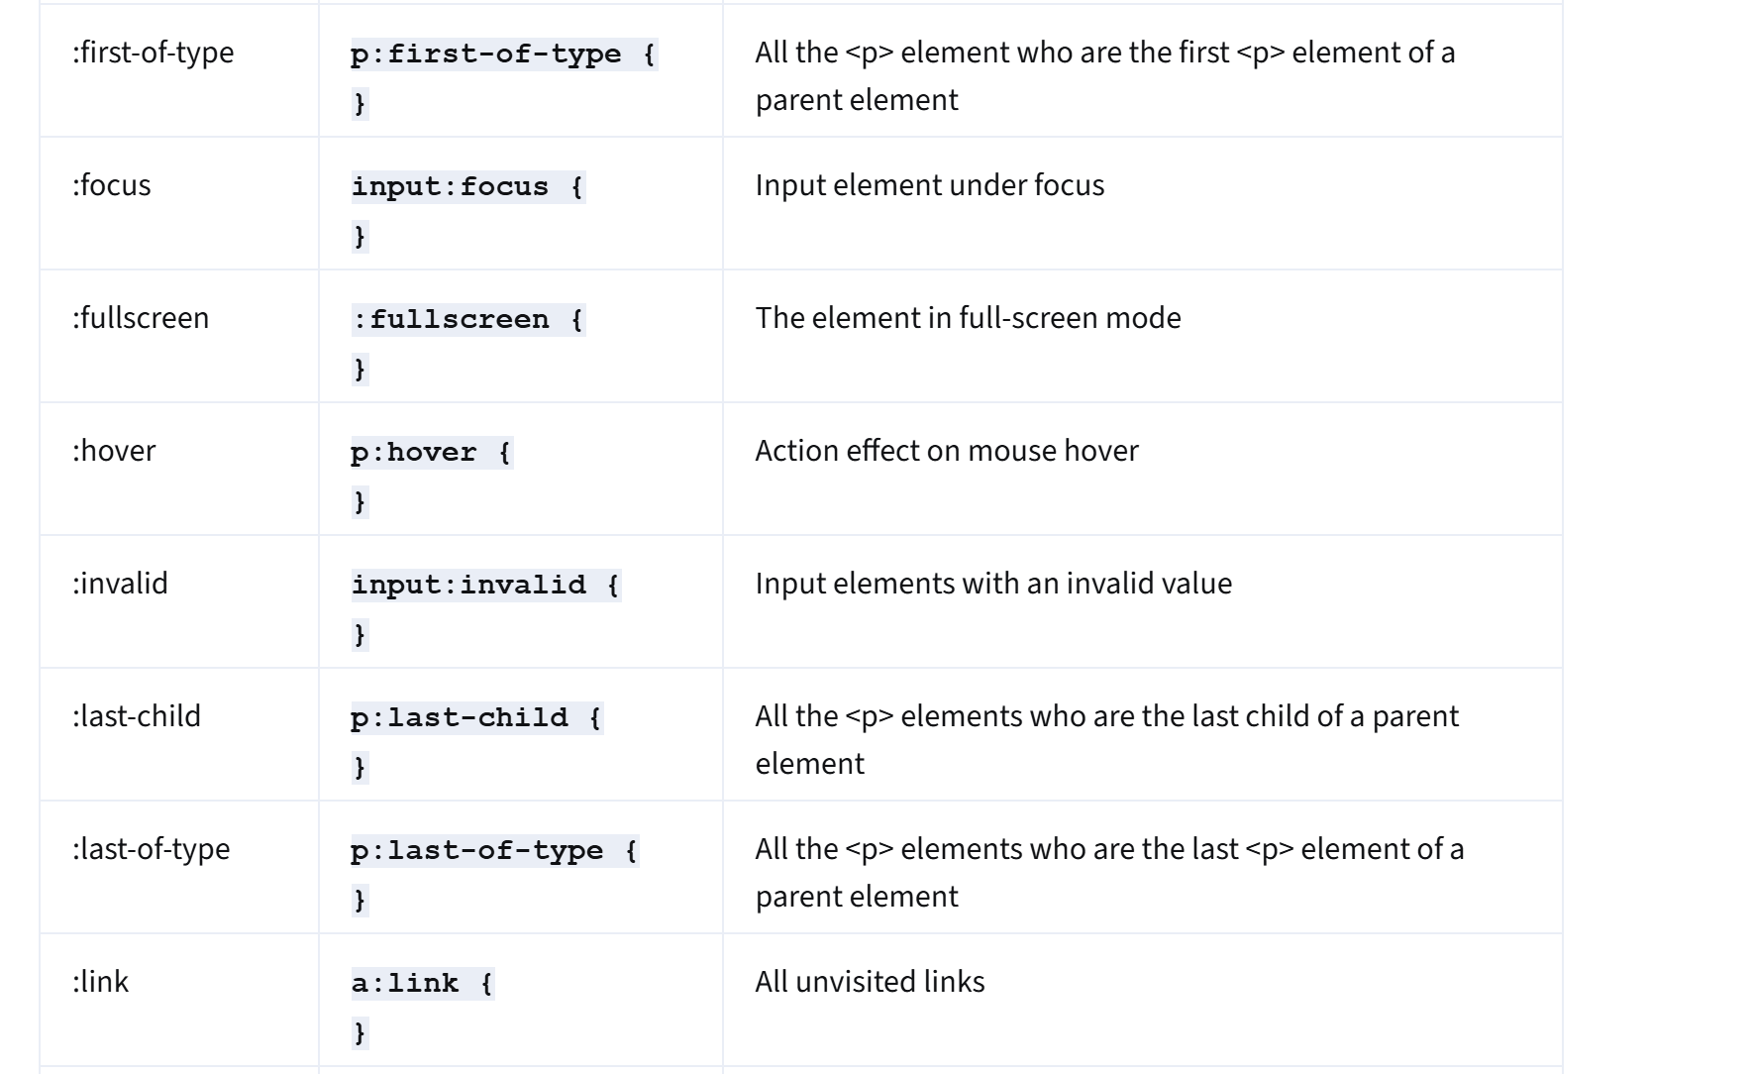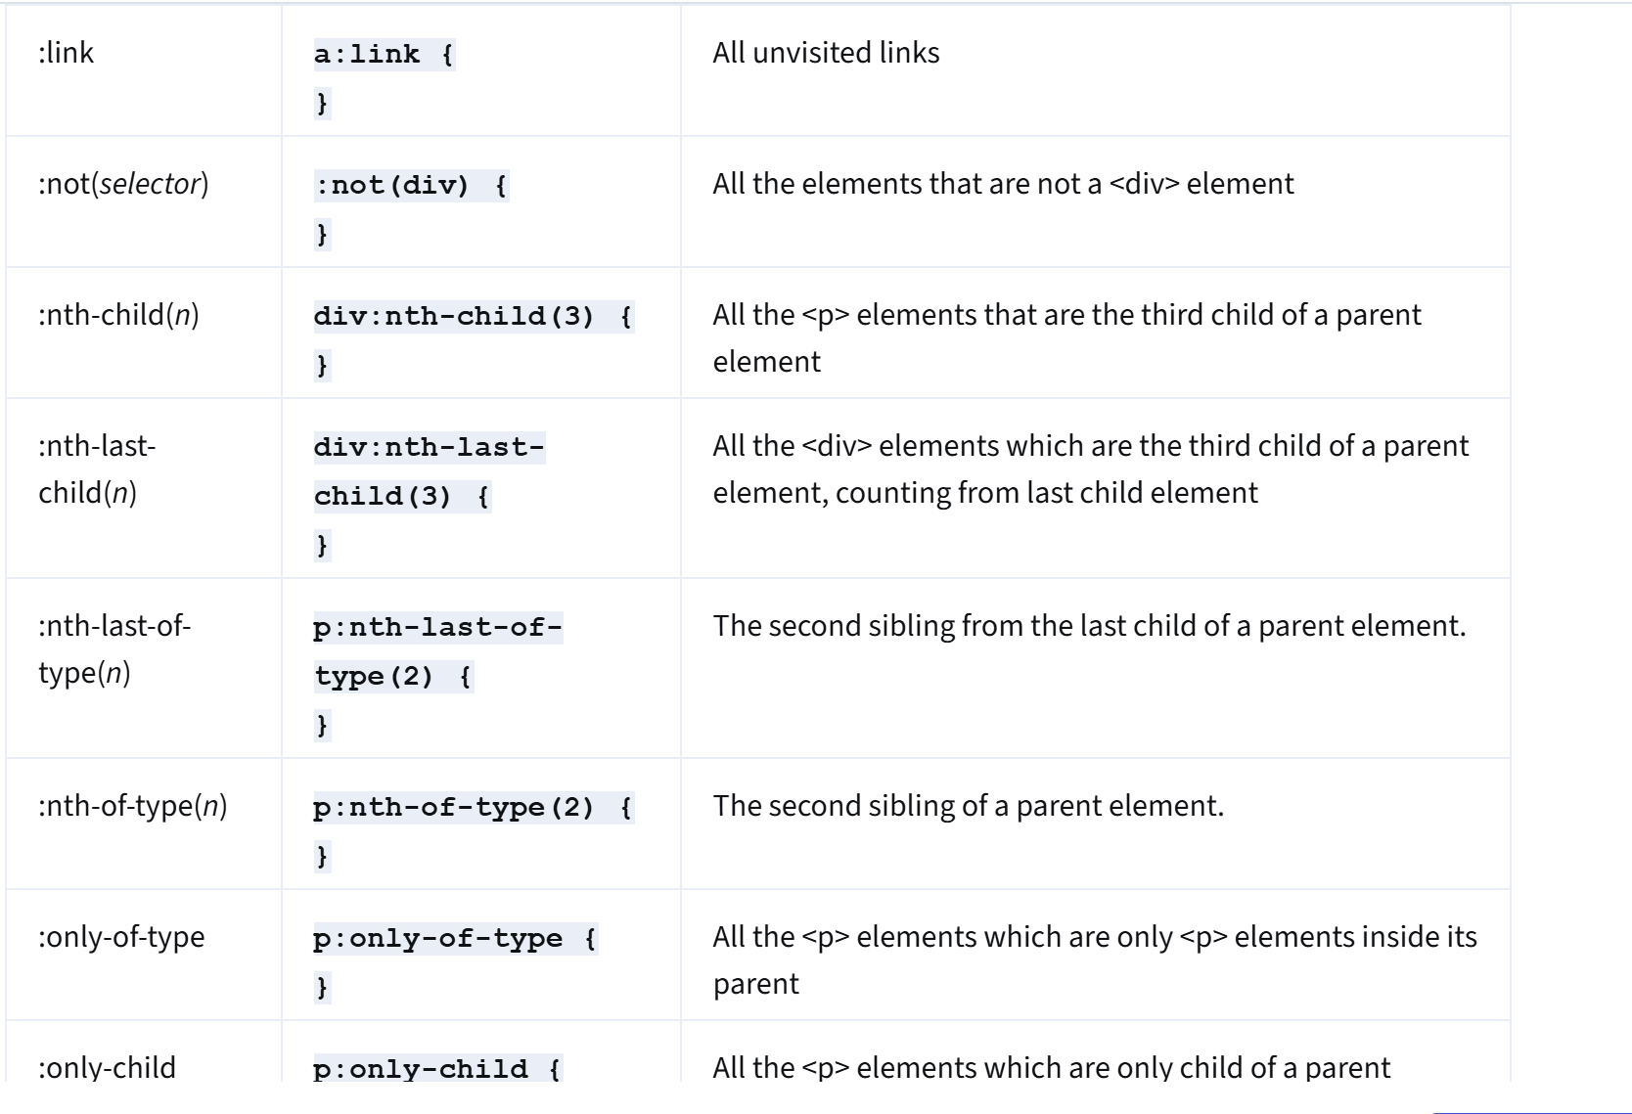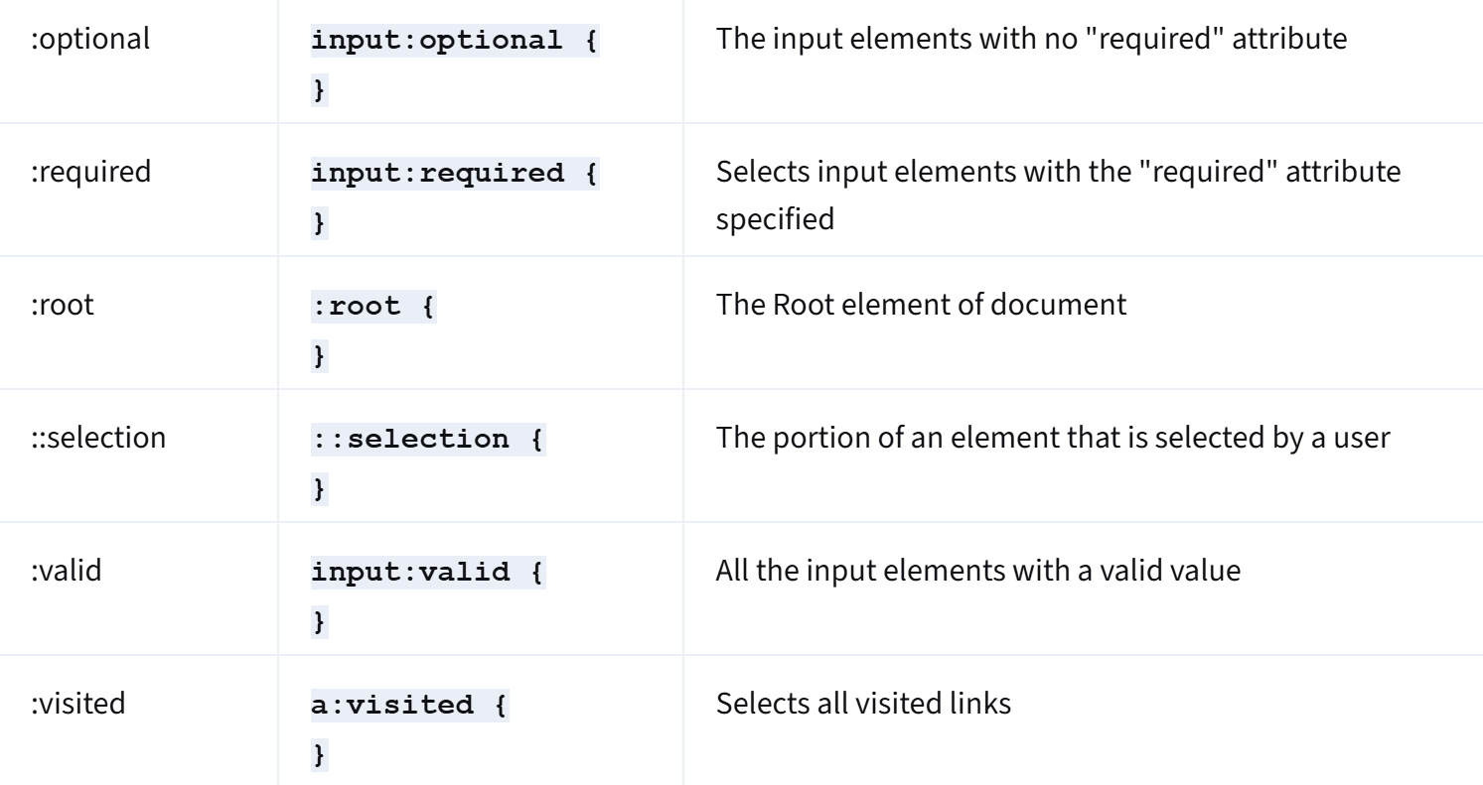  
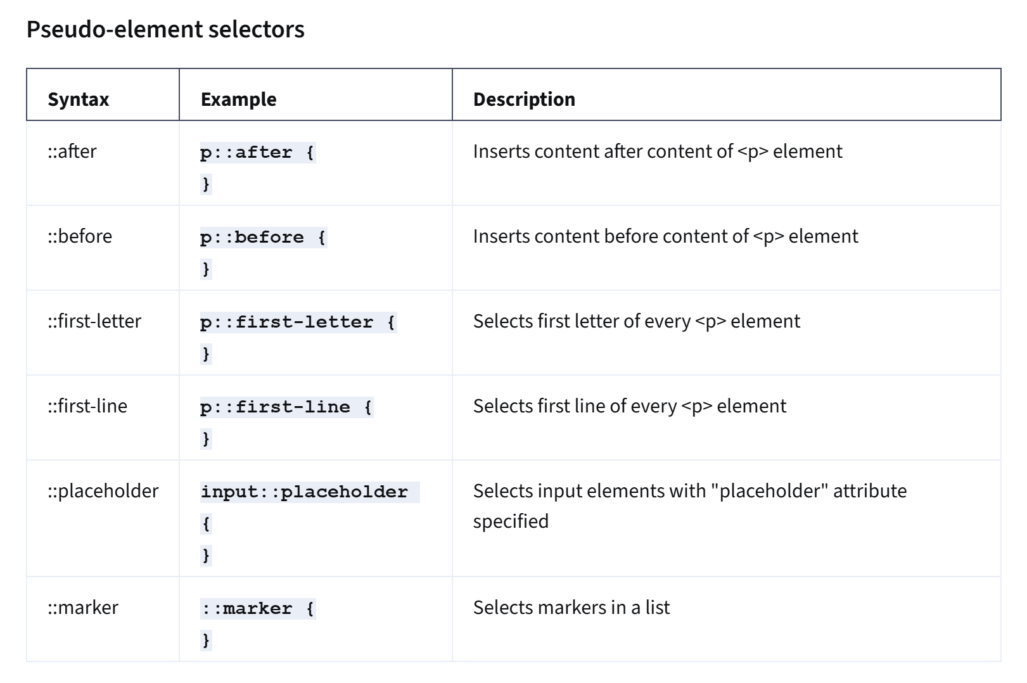  
  
additional resources**[**https://developer.mozilla.org/en-US/docs/Web/CSS/Pseudo-elements**](https://developer.mozilla.org/en-US/docs/Web/CSS/Pseudo-elements)[**https://developer.mozilla.org/en-US/docs/Web/CSS/Pseudo-classes**](https://developer.mozilla.org/en-US/docs/Web/CSS/Pseudo-classes)[**https://www.w3schools.com/cssref/css_selectors.asp**](https://www.w3schools.com/cssref/css_selectors.asp)[**https://developer.mozilla.org/en-US/docs/Learn/CSS/Building_blocks/Selectors/Combinators**](https://developer.mozilla.org/en-US/docs/Learn/CSS/Building_blocks/Selectors/Combinators) **https://www.geeksforgeeks.org/10-css-selectors-every-developer-should-know/  
  
CSS effects  
  
what is effect?**a change which is a result or consequence of an action or other cause.  
  
**animation**graphics in motion transitioning over time.  
  
GIFs graphic interchange format in 1987  
gif -> flash ->css  
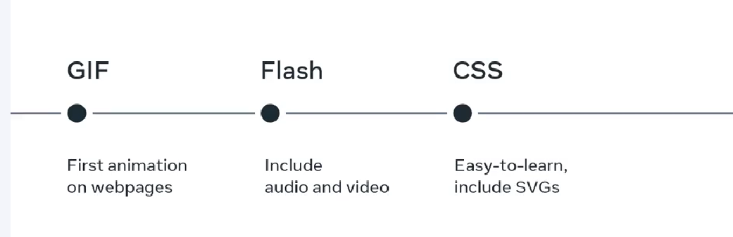  
  
jquery is a library for animation.  
  
css effects easy to learn.  
  
hover effect  
Curser effect  
sliding backgrounds  
video backgrounds  
parallax fore ground element moves faster then background elements.  
back to top effect  
elements and color transitions  
full screening snaping   
  
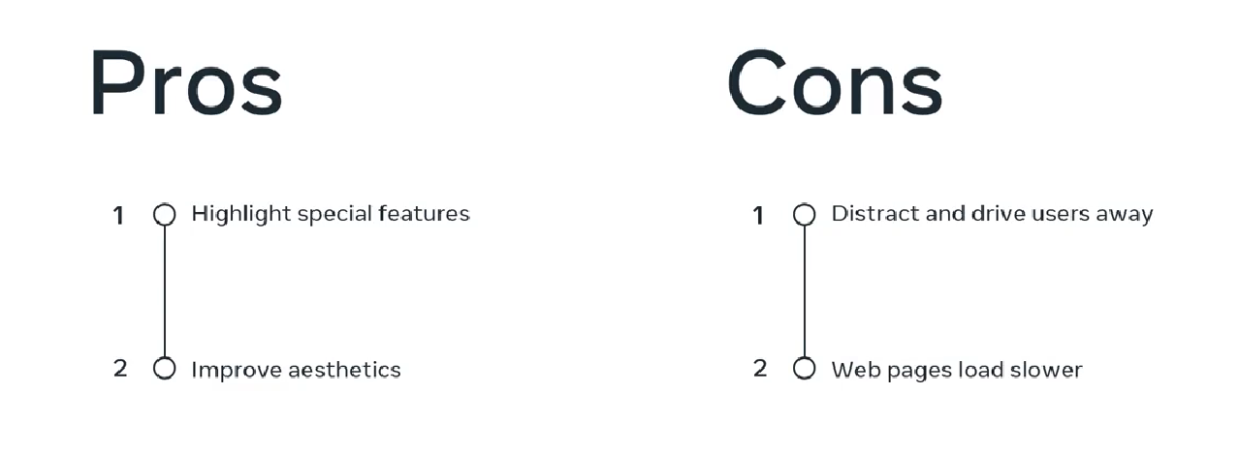  
  
text effects  
  
Ellipses property  
  
text effects cheat sheet  
  
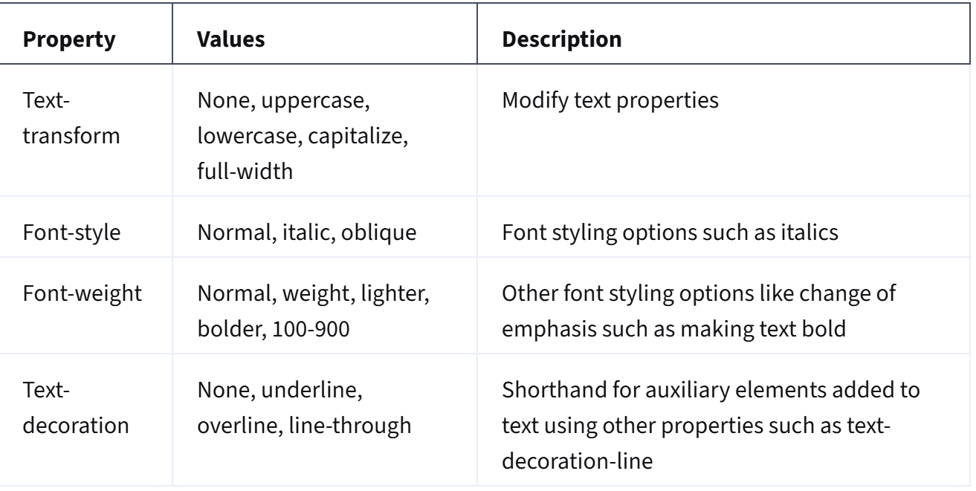  
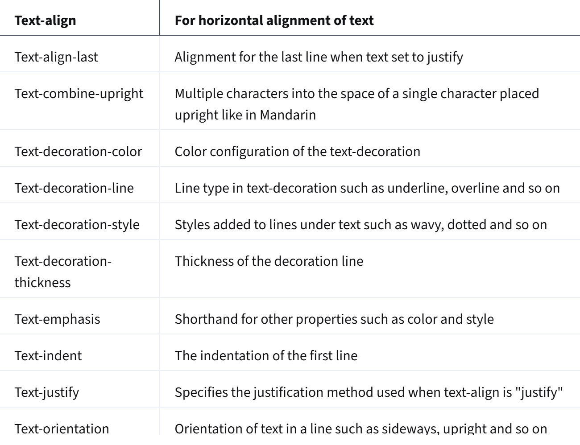  
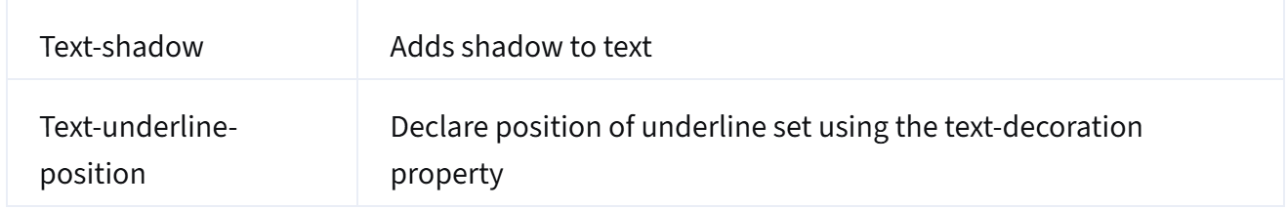  
  
  
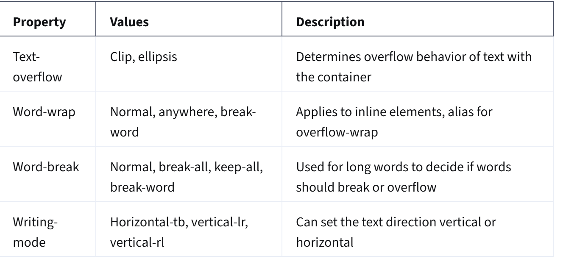  
**CSS transforms and transitions**  
  
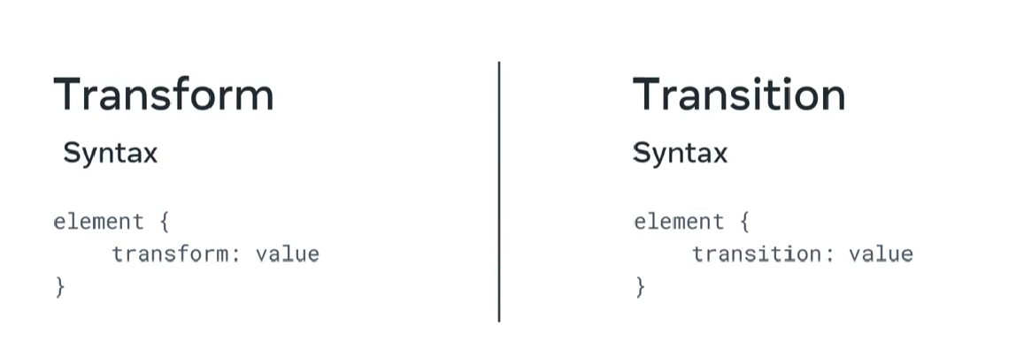  
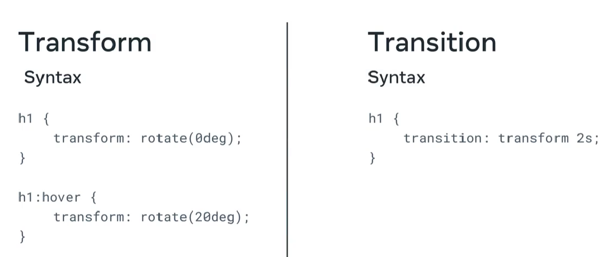  
  
**CSS animation  
  
animation property  
@key frames rules  
  
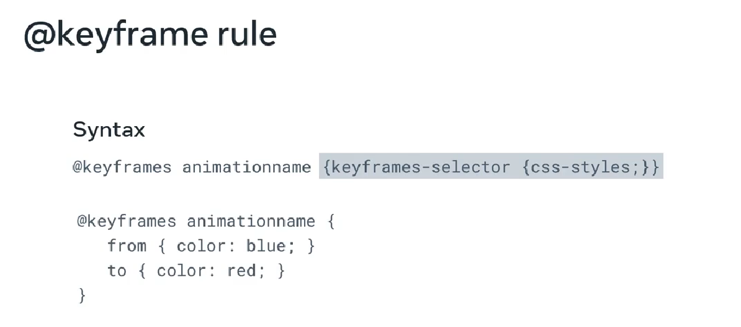  
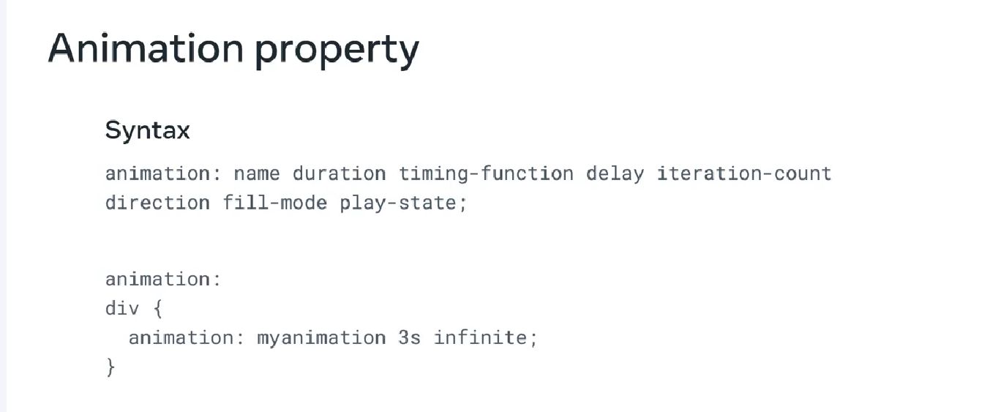  
  
want simple?  
animation: name duration timing-function  
  
@keyframes animation-name {**

**from {**

**property-a: value-a;**

**}**

**to {**

**property-a: value-b;**

**}**

**}**

**@keyframes identifier {**

**0% {transform: rotate(100deg);}**

**30% {opacity: 1;}**

**50% {opacity: 0.50;}**

**70% {opacity: 1;}**

**100% {transform: rotate(50deg);}**cheat sheet  
  
.sample-class {

    transform: rotate(60deg);

}  
  
.sample-class {

    transform: none;

}

.sample-class {

     transform: matrix(1.0, 2.0, 3.0, 4.0, 5.0, 6.0);

}

.sample-class {

    transform: rotate3d(3,2,1, 100deg);

}

.sample-class {

    transform: translate3d(10px, 20px, 30px);

}

.sample-class {

    transform: scale3d(2, 1, 0.3);

}

.sample-class {

    transform: skew(100deg);

}

.sample-class {

    transform: inherit;

}  
  
.sample-class {

    transform: initial;

}

.sample-class {

    transform: revert;

}

.sample-class {

    transform: revert-layer;

}

.sample-class {

    transform: unset;

}

.sample-class {

    transform: rotate(45deg) scale(1.5) translate(45px);

}

.sample-class {

    transform-origin: 10px 10px;

}

.sample-class {

    transform-origin: right bottom;

}

**Transition shorthand**

Transition shorthand has four following sub-properties, each of which can also be individually defined.

* transition-property
* transition-duration
* transition-timing-function
* transition-delay
* .sample-class {
* animation: none 2 ease 0.5 4 normal none running;
* }

animation-name

animation-duration

animation-timing-function

animation-delay

animation-iteration-count

animation-direction

animation-fill-mode

animation-play-state  
  
@keyframes mymove {

  from {property: value}

  to { property: value }

}  
  
@keyframes animation-name {

    from {bottom: 0px;}

    to {bottom: 100px;}

}

@keyframes animation-name {

/* declare actions here */

}

@keyframes animation-name {

    0%,100%{

        background-color: blue;

    }

    50% {

        background-color: green;

    }

}

#some-class{

    animation: animation-a 2s linear infinite alternate,

        animation-b 3s ease infinite alternate;

}

**Preprocessors: sass, scss**

**SASS and SCSS**

Syntactically Awesome Style Sheets (SASS) is a scripting language that CSS compiles and interprets into CSS. SCSS, which stands for Sassy CSS is the syntax for SASS and can be seen as an advanced version of both SASS and CSS. The difference between SASS and SCSS is best explained by the SASS documentation, which states:  
  
regular  
body {

    font: 100% Arial;

    color: lightblue;

}   
  
SCSS  
$font-stack: Arial;

$primary-color: lightblue;

body {

  font: 100% $font-stack;

  color: $primary-color;

}

SASS  
$font-stack: Arial

$primary-color: lightblue

body

  font: 100% $font-stack

  color: $primary-color

**Syntax**

@mixin *name*{ *property*: *value*; *property*: *value*;   ... }

@mixin some-rules {

    color: lightblue;

    font-size: 25px;

    font-weight: bold;

}

div {

    @include some-rules;

}

add(a, b)

  a + b

div

  margin add(10px, 20px)

Additional sources  
  
https://freefrontend.com/css-animation-examples/  
  
https://goingclear.com/website-effects/  
  
https://www.opendesignsin.com/blog/10-web-design-effects-to-enhance-your-website/  
  
<https://dev.to/kiranrajvjd/simple-text-effects-using-css-3dgp>  
  
https://freefrontend.com/css-typing-text/  
  
https://uicookies.com/css-text-effects/  
  
<https://developer.mozilla.org/en-US/docs/Web/CSS/@keyframes>  
  
<https://www.w3schools.com/css/css3_animations.asp>  
  
https://www.lambdatest.com/blog/css-transforms-and-transitions-property/  
  
**DEBUGGING**  
  
common errors  
  
common errors?  
skill-based errors

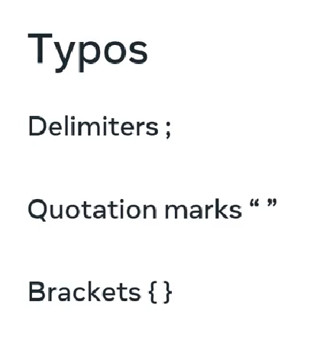  
  
syntax error

**Rule based error**  
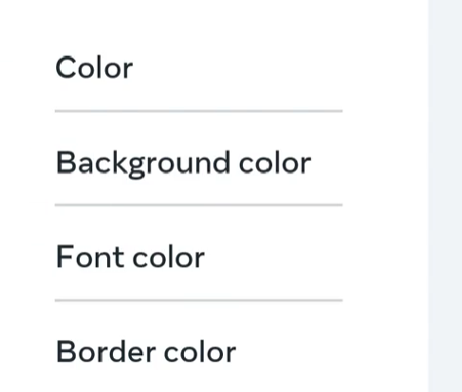  
  
knowledge based error  
  
use shorthand  
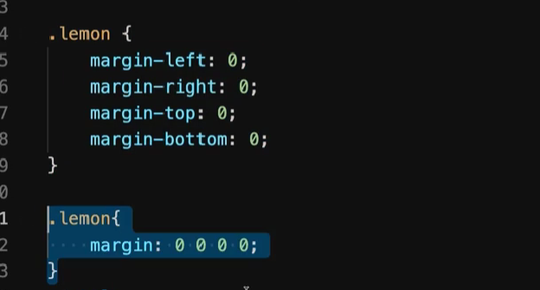  
  
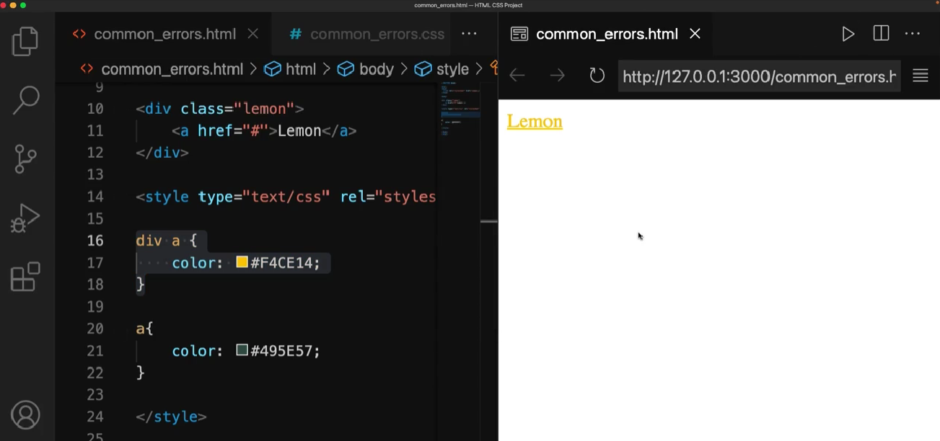  
  
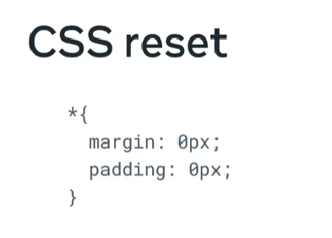  
**handling errors**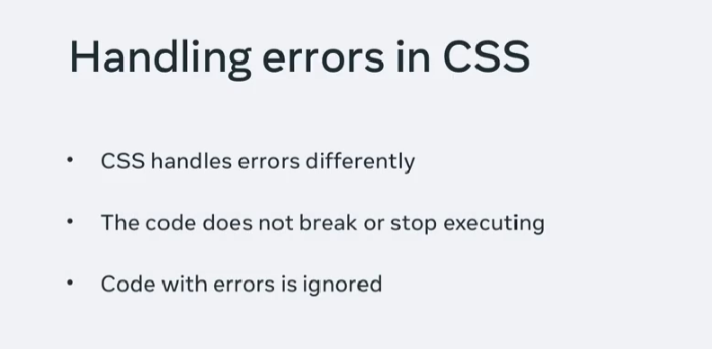Debugging the front-end

The first step in debugging CSS is to find the root of the issue and isolate the elements involved. The majority of CSS issues will be with the layout, such as:

* Content overflow from parent to child or container class
* Misplaced elements in relation to its container class
* Browser and device-related inconsistencies resulting in variable viewports
* **Isolation by reduced test case**
* **Items inside containers**
* **Relocating items**The CSS compiler reads the elements from right to left. As an example, for a selector such as div .alpha > p, the element read first will be p before moving ‘outside’. When you change the position of the p from inside the .
* **Getting familiar with the box model**
* **Browser issues**

**Debugging tool**  
developer tools  
different diagnoses

Error logs, debug java script, inspect HTTP , java script   
performance, CSS grids and flexbox layouts, HTML CSS rendering, live editing.  
  
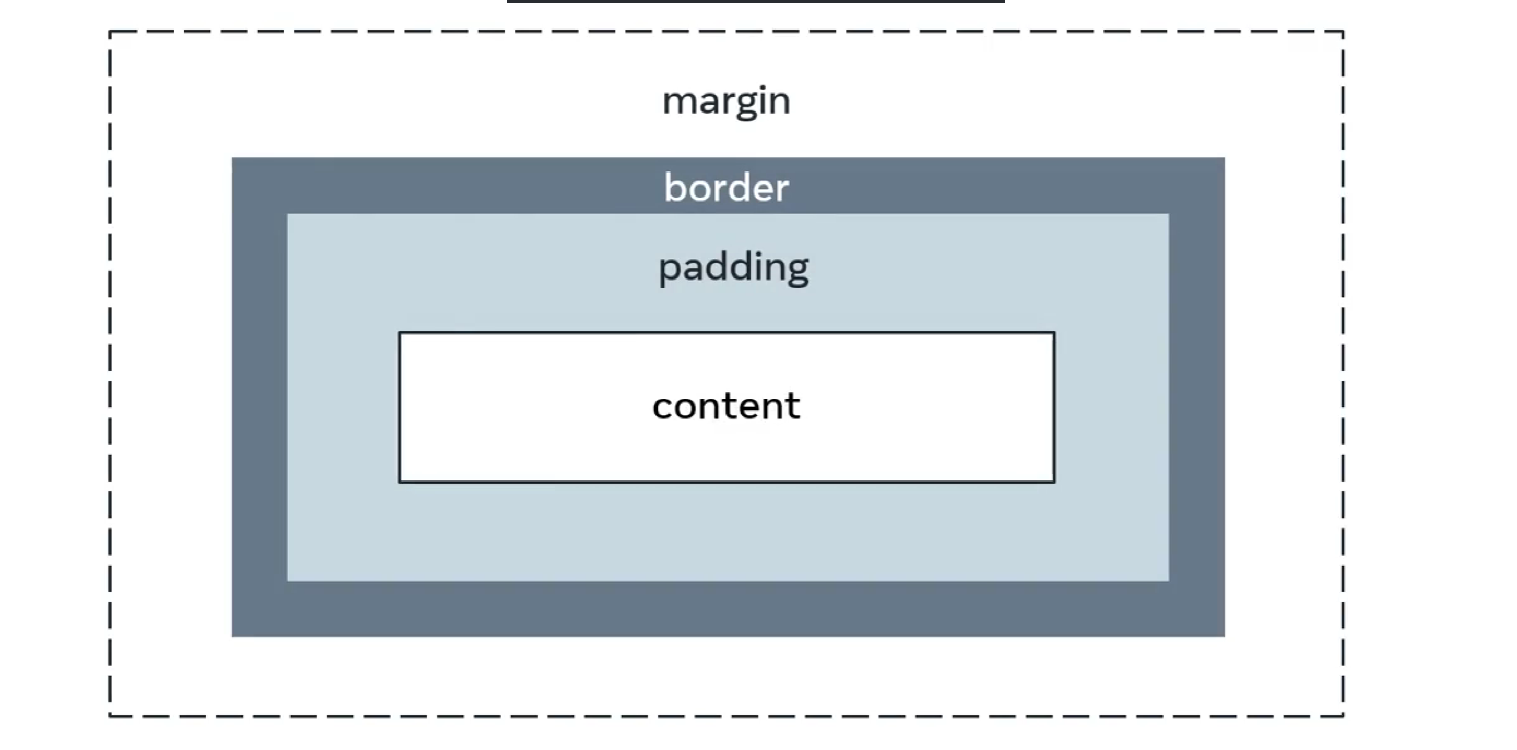  
 **Browser specific CSS**each browser has it own Default CSS properties for HTML elements.  
and own rendering engine.  
  
flex and grid layouts.  
various web sites to check the code Is compatible

Also check in mobile phones.  
  
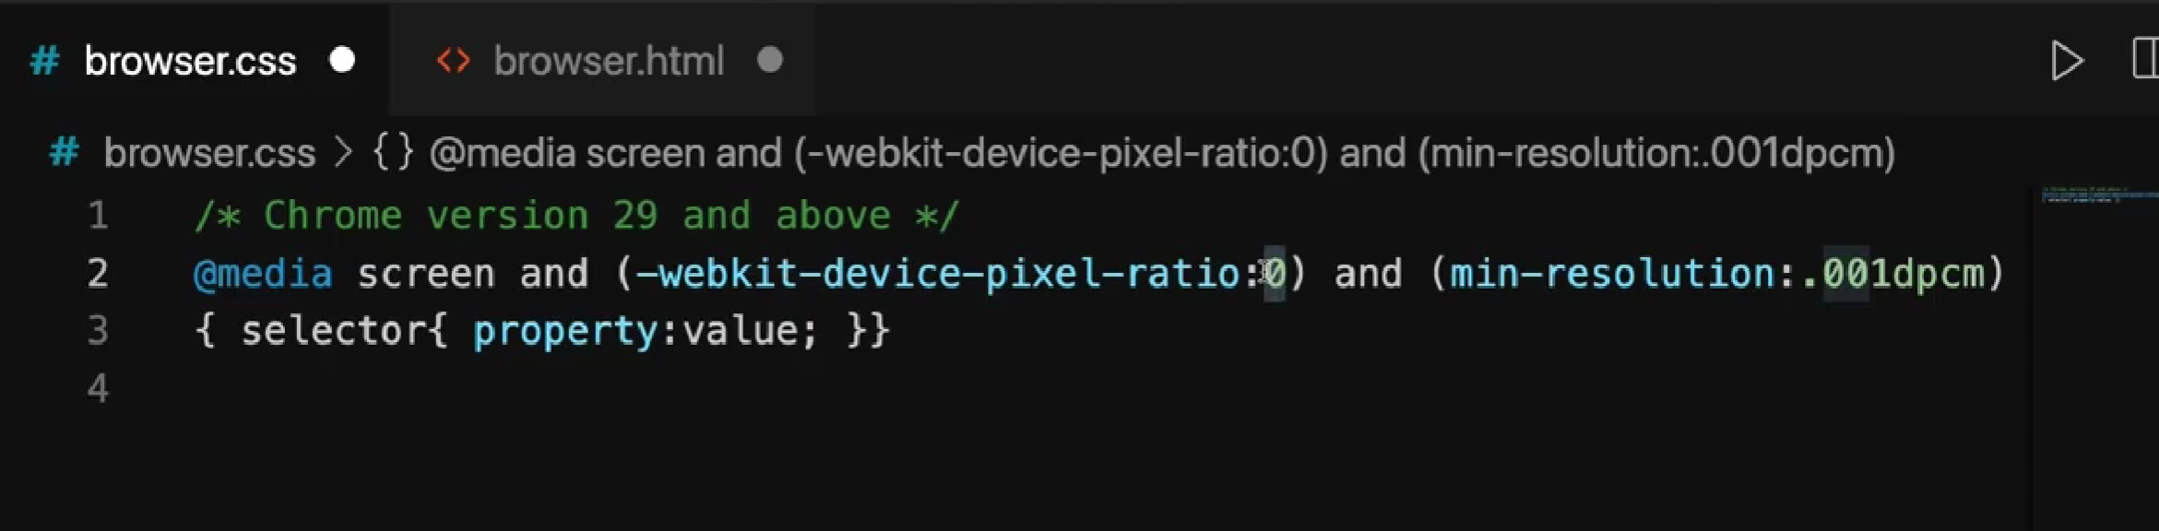  
many library’s to check the css is compatible  
  
modernizer   
reset.css  
normalize.css

use css.reset file  
that will reset the default rules.  
  
  
**UI testing**business priority, customer satisfaction  
  
common techniques  
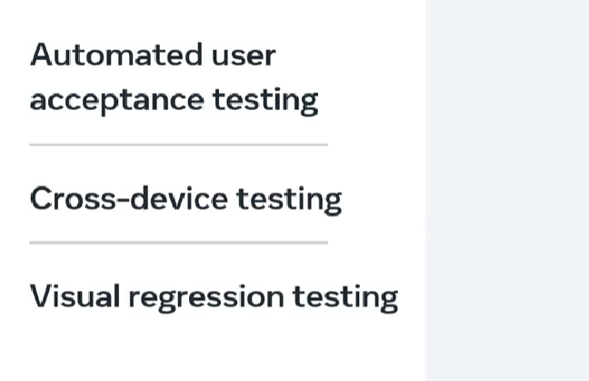  
  
cross device testing  
goal user experience in different devices  
  
in developer tools

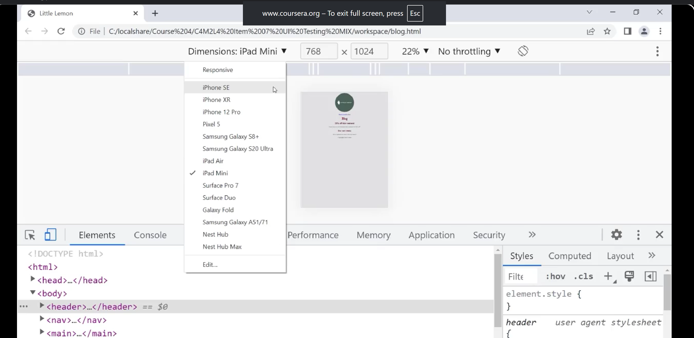  
  
in network settings can simulate different mobile network speeds,  
also use cpu slow down to check is working In older device  
  
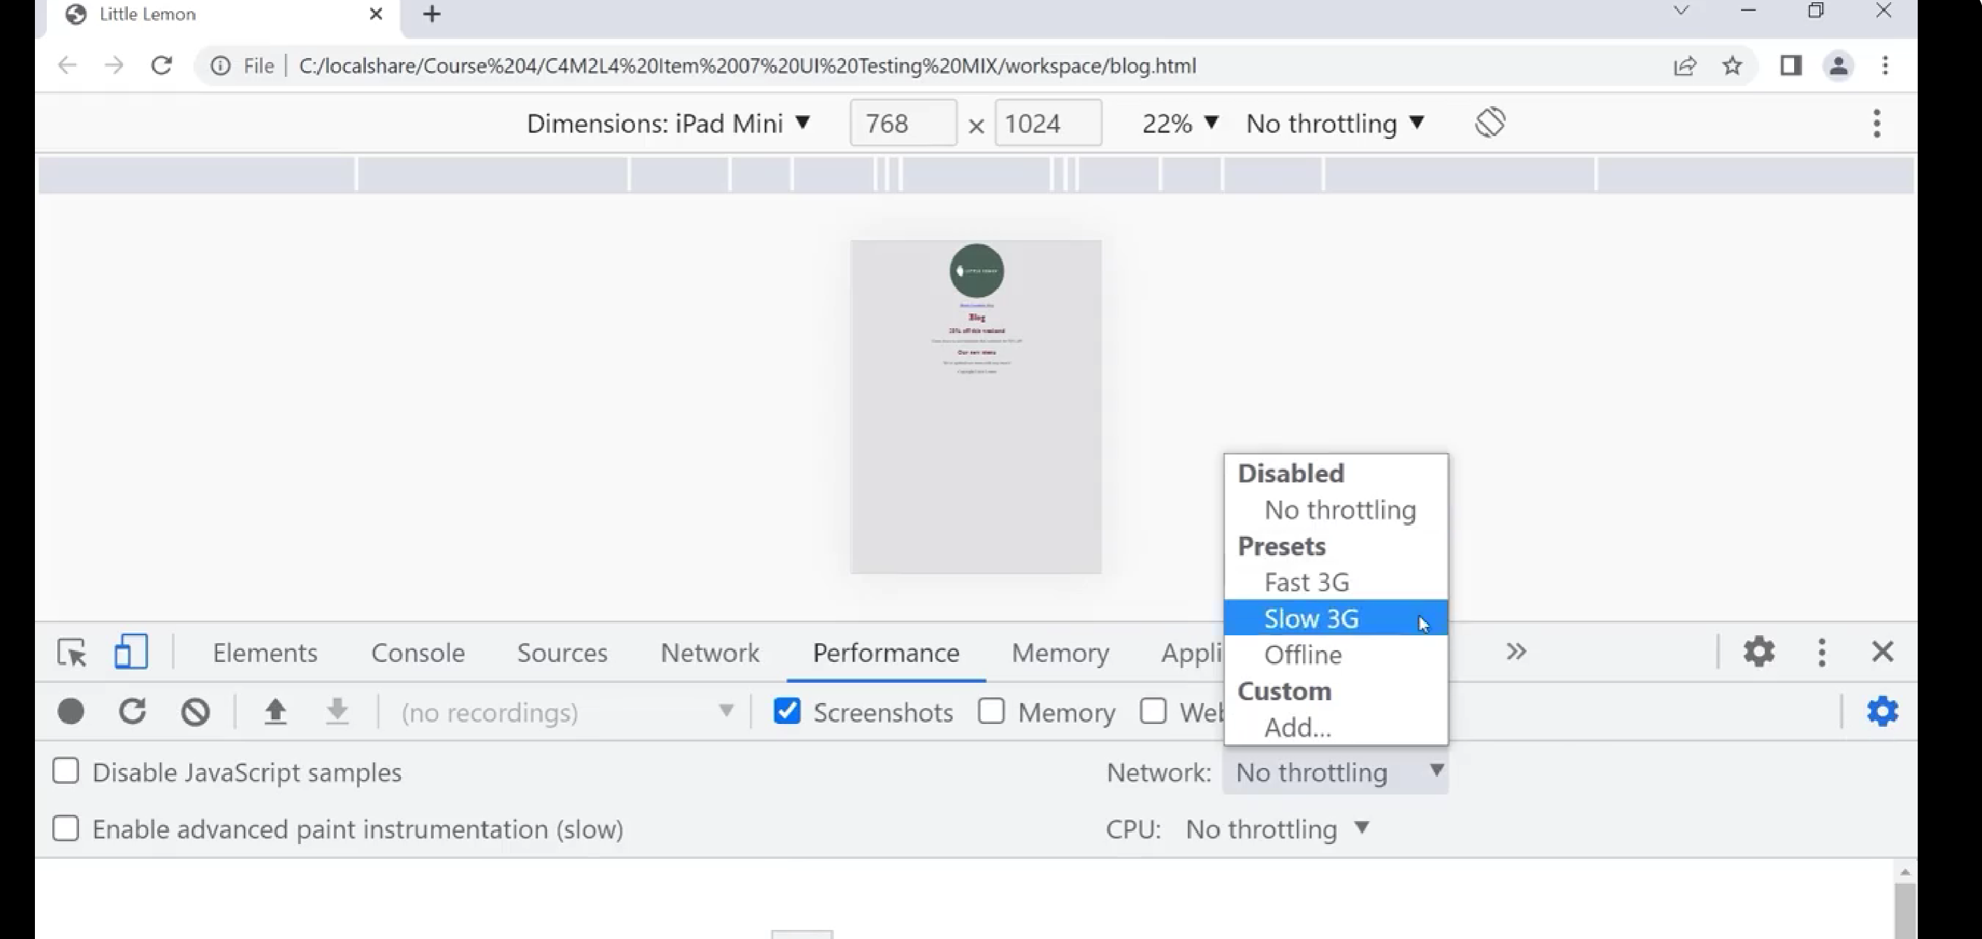  
  
many tool available run in vm  
  
additional resources  
  
https://www.lambdatest.com/blog/top-5-browser-compatibility-issues-in-css-for-developers-in-2021/  
  
<https://www.simplilearn.com/tutorials/css-tutorial/webkit-css>  
  
https://www.webfx.com/blog/web-design/12-common-css-mistakes-web-developers-make/  
  
https://www.sitepoint.com/study-errors-beginners-make-learning-html-css/  
  
https://www.freecodecamp.org/news/how-to-tackle-css-specificity-issues-and-when-to-use-the-important-keyword-b54123995e1a/  
  
https://jigsaw.w3.org/css-validator/  
  
http://csslint.net/  
  
https://stylelint.io/  
  
https://caniuse.com/  
  
**difference between UI and UX**  
  
**UX**

How use experience the hole  
presentation  
flow  
ease of use  
  
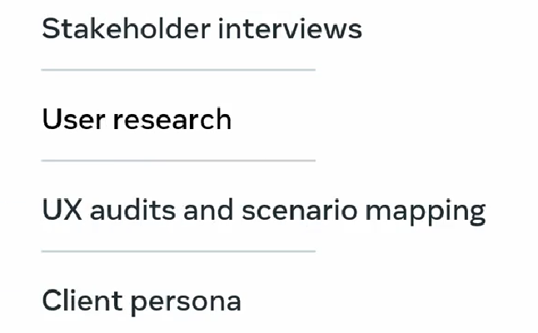  
  
intentional engagement  
keep the user interactive.  
  
improve access to information

**Creating themes**Fundamentally all colors are a combination of the three colors: red, yellow, and blue. These are called the primary colors. Secondary colors like orange, purple and green are a combination of two primary colors. Finally, there are six tertiary colors formed from a combination of the three primaries with secondary colors. By adding more black or more whiteyou can create lighter or darker tints of each color. All of these colors and tints make upa color wheel of 12 colors. This color wheel is the foundation for any color scheme.

Depending on the relative positions of colors on the wheel, there are seven commonly identified color schemes according to color theory that can be used for maximum appeal. These are:

·       Monochromatic

·       Analogous

·       Complementary

·       Split complimentary

·       Triadic

·       Square and

·       Rectangle

The different combinations represented in the image below. 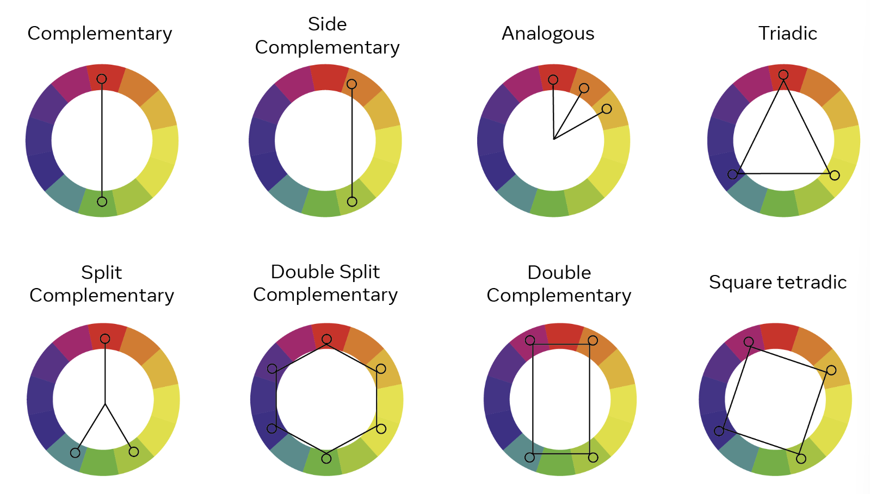 are